A Systematic Literature Review of Digital Twin Applications for Design-for-Safety and Design-for-Quality in the AECO Industry: Toward a Self-Improving Cognitive Digital Twin

Author: Hu TianYu, Department of Architecture and Civil Engineering, City University of Hong Kong
Supervisor: Prof. Thomas Ng
Version: v1.8 [20260906]

Abstract
The Digital Twin (DT) concept has attracted popularity as a strategic and new paradigm for the built environment industry seeking to improve efficiency. Yet its application in phases prior to operation stage remains fragmented and whether existing systems can learn and improve their own predictions over time has not been clearly addressed. This review therefore has objectives twofold. First, to map the bibliometric landscape of DT research addressing design and construction phases. Second, to determine the extent to which current DT systems exhibit self-improving and cross-phase capability. In this study, a scientometric analysis was conducted for 152 bibliometrics-searched articles of DT in built environment industry to provide a critical understanding of current research trends and gaps to address. The review found that despite the growth of publication in the field, the current studies remain confined to the one-way or static DT and highly concentrated in operations phase. None of current study attain a cognitive self-improving or convergence capability. Research is overwhelmingly single-phase and methods to support autonomy such as reinforcement learning, graph neural networks and large language models, are almost underexplored. These results provide quantified evidence that a self-improving cognitive digital twin (CDT) does not yet exist in built environment industry. In response, this study proposes a CDT framework of which the innovations are threefold: a cross-phase forward predictor linking design geometry to downstream safety and quality risks, leading-indicator-driven learning that improves without waiting for actual accidents, and a cross-project convergence loop that unifies design prediction.

Keywords: Cognitive Digital Twin; Design-for-Safety; Design-for-Quality; Built Environment; Systematic Literature Review; Bibliometric Analysis

- Introduction
  - The AECO Industry's Phase-Fragmented Delivery Problem
Digital Twin concept was originally proposed by Grieves and Vickers [1] as a mechanism for mitigating unpredictable emergent behavior in complex systems. It has rapidly evolved into a strategic paradigm for the digital transformation of infrastructure sectors. Within the Architecture, Engineering, Construction, and Operations (AECO) industry specifically, Boje, et al. [2] proposed a semantic construction digital twin framework and explicitly identified lack of cyber-physical integration and cognitive adaptation as critical unaddressed challenges, while Opoku, et al. [3] mapped the diverse but fragmented application landscape across various phases of construction projects. The previous study and discussions on digital twin are enormous and broadly distributed into various phases of life cycle and application fields with dispersed purposes. Building upon these foundational contributions, this study aims to review the current state of DT application and the barriers preventing its further development towards high intelligence.

  - Design-for-X as cross-phase analytical lens
Design-for-X (DfX) refers to an approach by which a specified downstream requirement of safety and quality are considered in upstream design decisions. Rather than treating these considerations as corrections to be made after design, Design-for-X seeks to anticipate them when design alternatives can still be evaluated and modified to achieve maximized total benefits in full life cycle [4].

In the AECO industry, performance of design decisions may not become observable until materialized in construction or operation. Permanent features such as openings, shafts, façade interfaces, access constraints and complex component connections can subsequently generate temporary-work requirements, work-at-height exposure, installation difficulties, defects or rework. Previous studies have accordingly examined Digital Twins for construction safety-risk management and quality management, although these applications remain dispersed across project phases [5, 6]. Existing Construction Digital Twin research has also identified lifecycle integration and the return of downstream information to earlier decision stages as unresolved requirements [2, 3, 7].

This review deliberately adopts safety and quality as analytical lenses and observable outcome domains through which cross-phase DT capability can be examined. Safety consequences can be traced through hazard assessments, near-miss records, protection requirements and incident records [8, 9], while quality consequences can be observed through dimensional deviations, inspection records, non-conformance and rework [10, 11]. As such, two traceable pathways are available for investigating forward prediction from design to construction and operation, and backward learning from realised outcomes. Within the proposed CDT, Design for Safety (DfS) and Design for Quality (DfQ) initially serve as prediction targets, while the underlying cross-phase learning architecture remains extensible to other Design-for-X objectives.

  - Preliminary Research Gaps
Existing papers categorized the DT maturity into 4 tiers as below table.

Table 1 Tiers classification of DT
Tier | Kritzinger, et al. [12] | Madni, et al. [13] | Arup [14] | Consolidated criterion
Tier 1  Digital Model | Digital Model  No automated data exchange | Pre-Digital Twin  Virtual prototype | Level 1: Linked to real-world system but lacking intelligence, learning or autonomy | No live data link; manual update only
Tier 2  Digital Shadow | Digital Shadow  One-way automated flow | Digital Twin  Mirrors physical state via sensors | Level 2: Some capacity for feedback and control, limited to small-scale systems | Automated one-way flow; monitoring only
Tier 3  Digital Twin | Digital Twin  Fully bidirectional | Adaptive Digital Twin  Adaptive interface, learns preferences | Level 3: Predictive maintenance, analytics and insights | Closed-loop, bidirectional; automated feedback
Tier 4  Cognitive /Self-improving | (beyond scope) | Intelligent Digital Twin  Reinforcement and unsupervised learning | Levels 4: learn efficiently from data, autonomous decision-making within a domain | Updates its own predictive model from realised outcomes; cross-phase; convergence-characterised
Tier 4  Cognitive /Self-improving | (beyond scope) |  | Level 5: autonomous reasoning, acts on behalf of users, incorporates lower-level twins

An evident conceptual-implementation gap exists in widely cited application frameworks. First, existing cognitive DT frameworks propose self-improvement conceptually but do not formalise convergence. For examples, Tao, et al. [7] proposes a conceptual function is proposed to describe the digital twin M_{DT}= f (Physical Entity, Virtual Entity, services; DT Data, connections) but it lacks convergence. Zheng, et al. [15] introduces iterative optimisation concept yet does not demonstrate self-updating mechanism nor convergence criterion. A contrasting variant of the same gap is that Schooling, et al. [16] in their DT-enabled anomaly-detection system for building O&M, adopt Bayesian on-line change-point detection deliberately because it does not require "prior knowledge of pre-change or post-change operation processes". It contains no mechanism for the digital twin to update its own model from operational data, leaving the self-improving convergence unaddressed. Second, existing closed-loop BIM by Pärn, et al. [17] feeds operation data back episodically without iteration. Knowledge-based feedback loop is proposed that return operational performance data from the O&M phase to designers and contractors but at one time without iteration, self-learning and is not instantiated. The mechanism by which such feedback would be continuously converged toward improved cross-phase decisions is left entirely unaddressed. The above peer-reviewed findings are consistent with the industry report of Arup [14] which revealed the progression and development of digital twins is far from reaching level 4 or 5. Based on the above preliminary findings, it is initially observed that cross-phase DT with forward prediction and convergence and backward self-improvement is underexplored.
  - Research Objectives
This review pursues these objectives:
- To map the bibliometric landscape and thematic evolution of Digital Twin research addressing DfX in the AECO industry, thereby characterising its publication trends, intellectual structure and foundational knowledge base.
- To assess the capability maturity of existing DT systems through full-text thematic synthesis, in particular the extent to which they exhibit cross-phase reasoning, self-improvement and convergence.
- To identify the methodological, lifecycle and validation gaps that constrain the DT capability.
- To synthesise the identified gaps into a conceptual framework for a self-improving CDT that couples a cross-phase forward predictor with a leading-indicator-driven, cross-project convergence loop for DfX forecasting.
- Research Methodology

Review Protocol
To achieve the research objectives, a Bibliometric-systematic literature hybrid methodology [18] is adopted following the PRISMA [19] framework and bibliometric analysis using VOSviewer [20]. Scopus and WoS database are selected as widely used in the field due to comprehensiveness. Eligibility Criteria and queries for inclusion of articles are as follows.

Table 2 Searching Eligibility Criteria
Criterion | Inclusion | Exclusion
Domain | AECO / built environment | Manufacturing, automotive, aerospace
Topic | DT + DfS or DfQ as primary focus | DT as buzzword
Publication type | Peer-reviewed journal article | Editorial, opinion piece, books
Language | English | Non-English(Chinese-language full texts indexed in CNKI) are excluded at screening.)
Period | 2015 to 4 July 2026 | Pre-2015, after 4 July 2026

Query 1:
Scopus: TITLE-ABS-KEY ( "digital twin" OR "cognitive digital twin" OR "digital shadow" ) AND TITLE-ABS ( safet* OR "design for safety" OR "prevention through design" OR incident* OR accident* OR hazard* OR defect* OR rework ) AND ( TITLE ( AEC OR AECO OR construct* OR "civil engineering" OR BIM OR building* OR infrastructur* OR "built environment" OR "built asset" ) OR KEY ( AEC OR AECO OR construct* OR "civil engineering" OR BIM OR building* OR infrastructur* OR "built environment" OR "built asset" ) ) AND PUBYEAR > 2014 AND PUBYEAR < 2027 AND ( LIMIT-TO ( SUBJAREA , "ENGI" ) ) AND ( LIMIT-TO ( DOCTYPE , "ar" ) )

Web of Science: TS=("digital twin" OR "cognitive digital twin" OR "digital shadow") AND TS=(safet* OR "design for safety" OR "prevention through design" OR incident* OR accident* OR hazard* OR defect* OR rework) AND (TI=(AEC OR AECO OR construct* OR "civil engineering" OR BIM OR building* OR infrastructur* OR "built environment" OR "built asset") OR AK=(AEC OR AECO OR construct* OR "civil engineering" OR BIM OR building* OR infrastructur* OR "built environment" OR "built asset"))
AND PY=2015-2026 AND DT="Article"

Table 3 Layer 1 of Primary Analytical Corpus
Source | Database search (Scopus + Web of Science)
Criteria | Query 1 + eligibility criteria
Theme | DT + AECO + safety/defect/rework
Number | 562
Source | Section 5 Bibliometric analysis + Section 6 Thematic synthesis
Analysis conducted | Title, key words and abstract; and  PRISMA screening

Table 4 Layer 2 of Supplementary Theoretical Foundations
Source | Backward snowballing via co-citation analysis
Criteria | Co-citation threshold ≥5 or distinct methodological role
theme | General DT theory + Reinforced Learning methodology + BIM foundations
Number | Total 12 nos. publications
Used for | Section 7 Discussion
Analysis conducted | Full text in-depth analysis

Two-Layer Corpus Structure as summarized in Table 1 and 2. Besides, backward citation searching via Co-citation Analysis is conducted following the PRISMA 2020 template with snowballing in systematic literature studies, supplementary citation searching is conducted to complement the primary database search. The snowballing procedure comprises two components. First, a systematic co-citation analysis was performed in VOSviewer on the Scopus subset of the corpus (n=381) to identify foundational works of the field. Second, a total of 21 cited-reference entries met this threshold of 5, corresponding to 16 unique publications after manual deduplication of variant citation formats. Of these, 9 unique publications were identified as not yet included in the primary corpus and therefore manually added as Layer 2 supplementary theoretical foundations, they are no.1 to no.9 as in table 4. A further set of 3 references achieving co-citation frequency between 3 and 4 are identified as methodologically indispensable for the review's argumentation and therefore included in the database.

Table 5List of publications Added via Backward Citation Searching as Layer 2 Supplement
No. | Layer 2 Publications | Co-citation Frequency | Theoretical Role | Reference
1 | Rezgui/Boje et al. (2020). Towards a semantic construction digital twin: Directions for future research | 13 | Construction DT domain integration; semantic layer articulation | [2]
2 | Grieves M. (2014). Digital twin: Manufacturing excellence through virtual factory replication | 5 | Original AECO-adjacent DT conceptualization | [21]
3 | Grieves M. & Vickers J. (2017). Digital Twin: Mitigating unpredictable, undesirable emergent behavior in complex systems. | 10 | Cognitive DT and emergent behavior theory | [1]
4 | Barlow C. et al. Digital twin: Enabling technologies, challenges and open research issues | 8 | Technology enablers framework | [22]
5 | Flath C.M. et al. Peeking into the void: Digital twins for construction site logistics. | 5 | Construction site logistics DT (applied domain) | [23]
6 | Girolami M. et al. Construction with digital twin information systems. | 7 | Data-centric DT information systems | [24]
7 | Holmstrom J. et al. Digital twin: Vision, benefits, boundaries, and creation for building. | 7 | DT vision and boundaries for AECO | [25]
8 | Kvamsdal T. et al. Digital twin: Values, challenges and enablers from a modeling perspective. | 7 | Modeling perspectives and value proposition | [26]
9 | Hicks B. Characterising the digital twin: A systematic literature review | 5 | DT characterization taxonomy | [27]
10 | Grieves M.W. (2005). Product Lifecycle Management: The new paradigm for enterprises. | 3 | Original PLM formulation—earliest DT concept articulation | [28]
11 | Sutton R.S. & Barto A.G. Reinforcement Learning: An Introduction | 3 | Reinforcement learning methodology foundation for Objective 2 | [29]
12 | Kritzinger W., Karner M., Traar G., Henjes J., Sihn W. (2018). Digital Twin in Manufacturing: A Categorical Literature Review and Classification. | 4 | DT/DS/DM three-tier categorization | [12]
In total, 12 supplementary theoretical foundations were added to the review via backward citation searching, constituting Layer 2 of the two-layer corpus structure.

PRISMA Flowchart
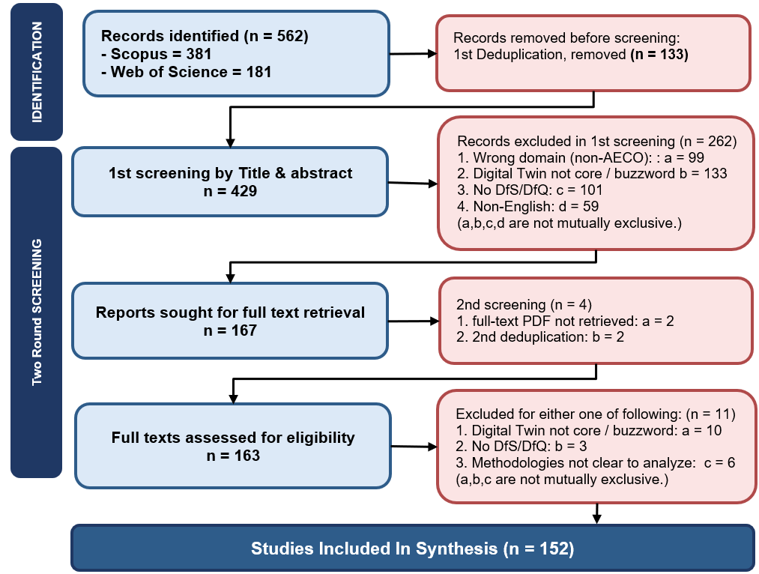
Figure 1 The review Screening procedures
In 2nd exclusion, records are excluded if they meet either one of the three criteria, resulting in a total of 11 nos. records are excluded. Finally, total 152 articles are included in the detailed full text analysis.
- Results
  - Publication Trends by Scopus

Year | Publication nos. | 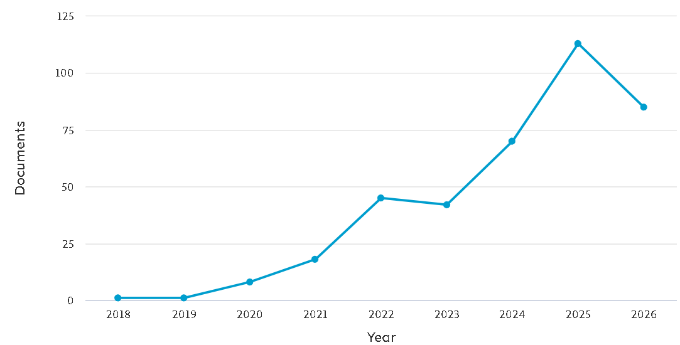
Jan - Jun 2026 | 83
2025 | 113
2024 | 70
2023 | 42
2022 | 45
2021 | 18
2020 | 8
2019 | 1
2018 | 1
Total | 381
Figure 2 Annual Publication nos. 2015-2026
Figure 2 presents the annual distribution of the 381 identified publications on Digital Twin in AECO addressing safety, quality, defect, and incident-related outcomes (2019–2026). The corpus exhibits a sharp growth trajectory from a single publication in 2019 to 113 publications in 2025, with 83 nos. additional publications identified in the first half of 2026 alone. This surge reflects several converging drivers: (i) the theoretical consolidation of Digital Twin frameworks following seminal AECO-specific formulations by Boje, et al. [2] and Girolami, et al. [24]; (ii) the industry-wide digitalization acceleration due to developed enabling technologies Zhang, et al. [5]; and (iii) the growing safety Luo, et al. [6] and quality Yue, et al. [30] demands imposed by increasingly complex infrastructure projects.

    - Temporal Evolution of Research Themes by Scopus

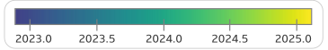
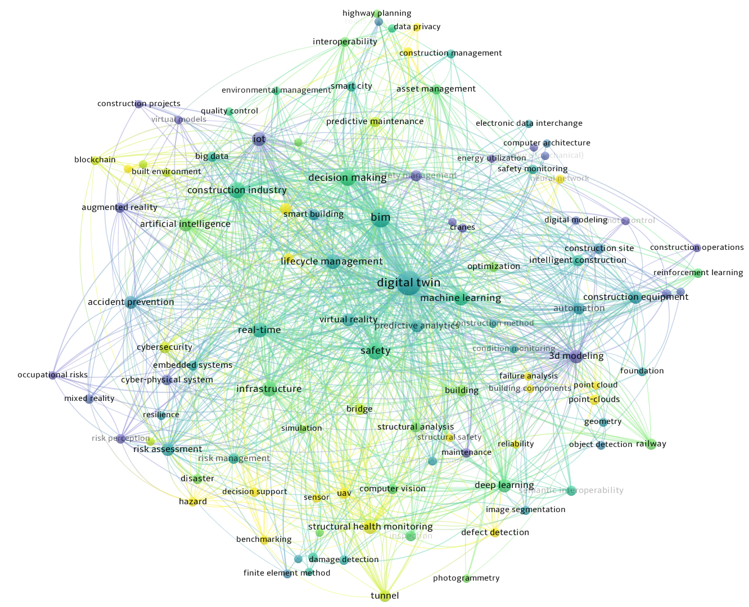
Figure 3 Publication Trends in themes (Scopus)
Figure 3 presents the overlay visualization of the keyword co-occurrence network, with node colour representing the average publication year of each keyword (ranging from 2023.0 to 2025.0). This temporal overlay reveals three distinct thematic phases in the recent evolution of DT-in-AECO research.

Phase 1 Foundational Consolidation (2023, purple nodes)
The earliest thematic cluster visible in the corpus is anchored by cyber-physical system, embedded systems, virtual models, computer architecture, mixed reality, 3d modeling, neural network, condition monitoring, and occupational risks. These keywords represent the mature foundational infrastructure of DT research, upon which more recent developments have built.

Phase 2 — Current Mainstream (2024, green nodes)
The central cluster of the network is dominated by digital twin, BIM, safety, machine learning, artificial intelligence, IoT, real-time, deep learning, risk assessment, infrastructure, construction industry, and lifecycle management. This phase represents the active mainstream of contemporary research, characterized by BIM–DT–AI integration for construction management and safety applications.

Phase 3 — Emerging Frontier (2025, yellow nodes)
The most recent thematic cluster features reinforcement learning, defect detection, damage detection, structural safety, structural health monitoring, predictive maintenance, intelligent construction, construction operations, image segmentation, point-clouds, blockchain, and data privacy. These nodes represent the current research frontier, characterized by the integration of reinforcement learning with defect and damage detection.
The temporal overlay reveals two critical structural observations relevant to the research gap identified in this review. First, the keywords most closely aligned with the present dissertation's objectives—reinforcement learning (Objective 2's core methodology) and defect detection (Objective 1's primary prediction target)—both exhibit the highest average publication years (>2024), positioning the proposed research directly within the emerging research frontier. Second, the notable absence from the visualization of keywords explicitly denoting cognitive digital twin, self-improving, or cross-phase convergence, all below the analysis threshold of 5 occurrences, empirically confirms that these specific formulations remain new even within the 2025 frontier. This dual observation is that the emergence of adjacent enabling technologies alongside the absence of integrated cognitive-convergence frameworks defines the precise theoretical gaps that the proposed research objective seeks to address.

    - Keyword Co-Occurrence Map by Scopus

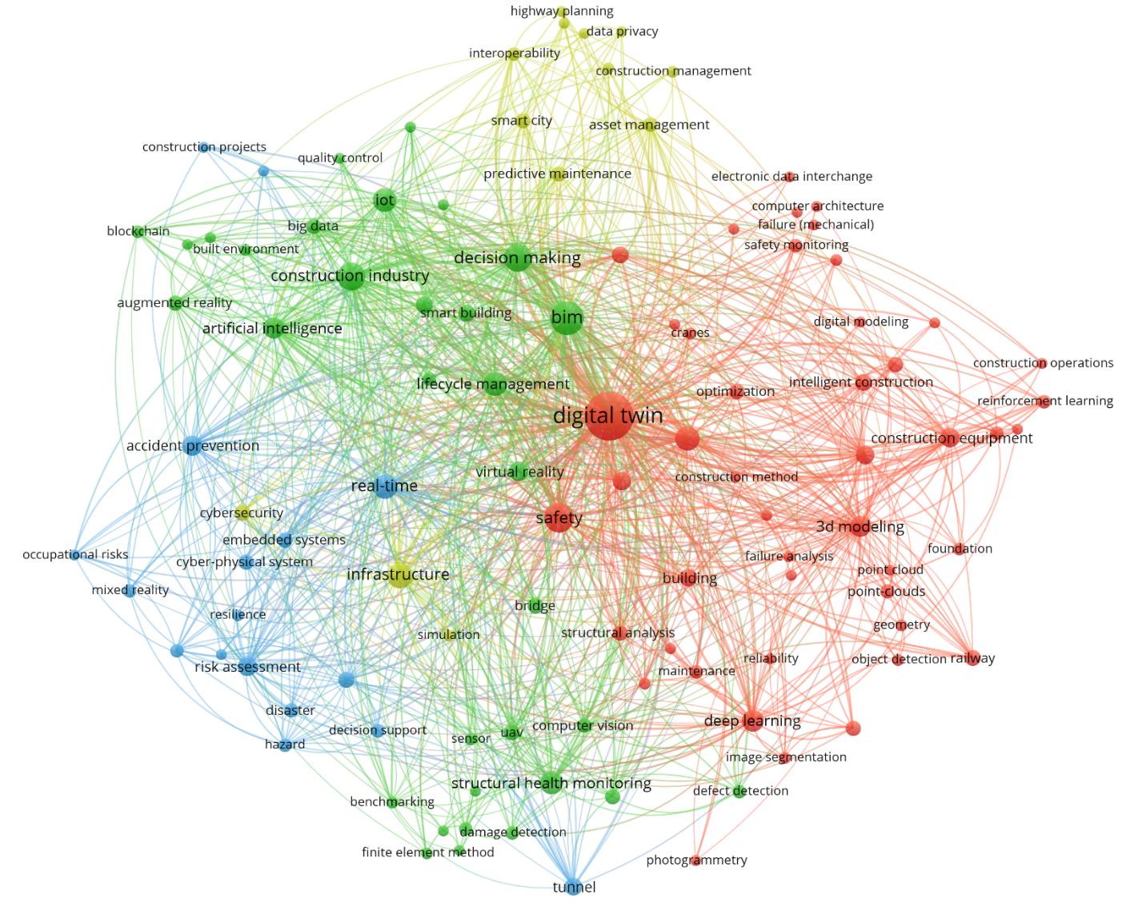
Figure 4 Keyword Co-occurrence Network (Scopus)

The keyword co-occurrence network is constructed using VOSviewer with the full-counting method, applying a minimum occurrence threshold of 5 to 3,786 unique keywords after thesaurus-based normalisation, resulting in 109 keywords retained. The analysis identified four thematic clusters, revealing the intellectual structure of digital twin research in the AECO industry.

Cluster 1 Digital Twin Core, AI, and Automated Sensing (red):
Anchored by digital twin (257 occurrences, the largest node) and integrating safety (52 occurrences), machine learning, deep learning, real-time, and reinforcement learning, this cluster represents the intellectual core of the field. It integrates AI-driven sensing technologies (3D modelling, point cloud, photogrammetry, object detection, image segmentation) with construction safety applications (safety monitoring, defect detection, damage detection, structural safety) and specific engineering contexts (construction equipment, intelligent construction, railway, excavation).

Cluster 2 Risk Assessment, SHM, and Accident Prevention (blue):
Featuring risk assessment, risk management, risk analysis, risk perception, hazard, disaster, resilience, and accident prevention, this cluster represents the DfS-oriented risk analytics stream. Structural monitoring aspects are represented by structural health monitoring, structural analysis, bridge, and tunnel. Methodological support is provided by Bayesian networks, finite element method, mixed reality, and embedded systems. This cluster reflects the field's transition from descriptive safety monitoring toward predictive, model-based risk analytics.

Cluster 3 — Infrastructure DT and Cybersecurity (yellow):
Centred on infrastructure, predictive maintenance, asset management, and smart city, this cluster addresses DT deployment at the infrastructure scale. Emerging operational concerns include cybersecurity, interoperability, edge computing, and data privacy. Transportation infrastructure sub-topics (motor transportation, roads and streets) form a distinct peripheral community within this cluster, reflecting DT applications in intelligent transport systems.

Cluster 4 — BIM, AI Decision Support, and Smart Building (green):
Comprising BIM (75 occurrences, the second-largest node), construction industry, information management, decision making, artificial intelligence, IoT, big data, and lifecycle management, this cluster represents the BIM-anchored DT paradigm. It extends into immersive technologies (augmented reality, virtual reality, virtual models), emerging technologies (blockchain, electronic data interchange), and sustainability applications (smart building, sustainability, built environment, energy efficiency, quality control). This cluster reflects the traditional information-management view of DT as a BIM extension supporting whole life-cycle decision-making.
The network reveals three important structural observations. First, digital twin occupies the geometric centre of the network with the highest total link strength, indicating that DT-in-AECO research is thematically well-integrated rather than fragmented across sub-fields. Second, the two largest secondary nodes of BIM and safety sit at the boundary of Clusters 1, 2, and 4, confirming BIM and safety as the dual foundational concepts organising the field. Third, the network reveals a notable absence of dominant nodes of self-improving, cognitive, or convergence-aware DT capabilities. Therefore, research gap is empirically confirmed that despite widespread DT adoption in AECO, self-improving cross-phase DT frameworks with convergence nature remain underexplored.
    - Co-citation Network Analysis by Scopus
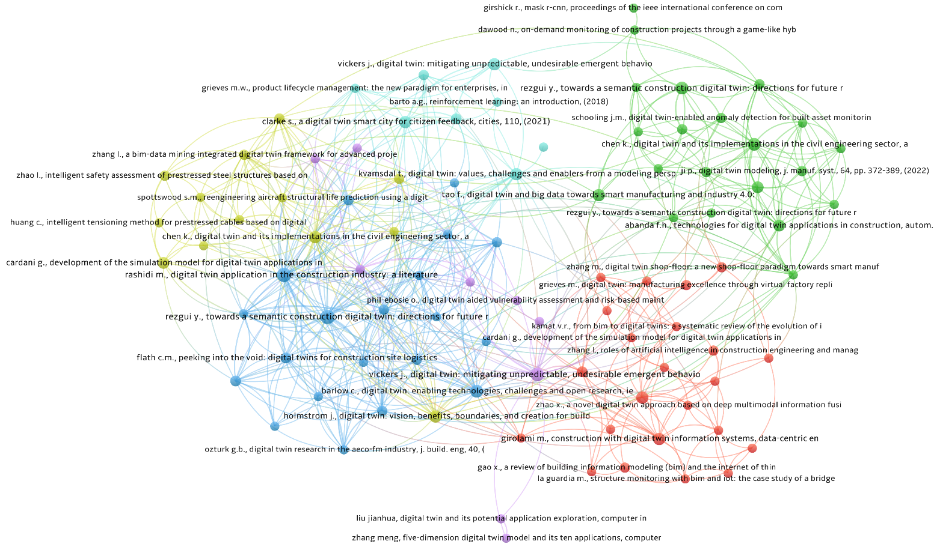
Figure 5 Co-citation network (Scopus)

The co-citation network of foundational works cited by the 381 corpus studies. Applying a minimum co-citation threshold of 3, 94 references were identified as belonging to the field's foundational knowledge base, organized into six thematic clusters. The network exhibits a distributed multi-centric structure, which means the knowledge in the field is yet consolidated to be commonly accepted outcomes.

Cluster 1 Manufacturing DT and BIM Integration (red, 23 items):
The largest cluster, anchored by Grieves [21], Zhang, et al. [31], Girolami, et al. [24] and Kamat, et al. [32]. This cluster represents the intellectual origin of DT theory in manufacturing and its foundational translation into BIM-anchored AECO applications.

Cluster 2 Civil Engineering DT and Anomaly Detection (green, 21 items):
Anchored by Boje, et al. [2], Schooling, et al. [16], Chen, et al. [33] and Tao, et al. [34]. Notably, this cluster contains the algorithm of R-CNN by Girshick Ross, et al. [35], which is an influential computer vision reference indicating DT's methodological borrowing from adjacent AI fields.

Cluster 3 BIM Foundations and Construction Site DT (blue, 20 items):
Featuring Barlow, et al. [22]. (enabling technologies), Flath, et al. [23] (construction site logistics), Kassem, et al. [36]. (built environment), Ozturk [37] (AECO-FM industry), and Taylor, et al. [38] (civil engineering 4.0). This cluster represents the BIM-anchored view of DT as an information management extension.

Cluster 4 DT Applied Reviews and Structural Applications (yellow, 13 items):
Anchored by Stargel and Glaessgen [39], Tao, et al. [7], Huang, et al. [40] and Grieves and Vickers [1] for mitigating emergent behavior, which appears here for the first time. This cluster bridges concept-oriented and application-specific DT works, particularly for structural safety.

Cluster 5 Cognitive DT and Vulnerability Assessment (purple, 9 items):
Comprising Bettenhausen, et al. [41] (importance of autonomy), Phil-Ebosie, et al. [42] (DT-aided vulnerability assessment), Zhang, et al. [43] (five-dimension DT model), and Grieves and Vickers [1]. This cluster represents the emerging stream integrating cognitive DT capability with structural vulnerability analysis.

Cluster 6 Foundational Theoretical References (cyan, 8 items):
The smallest cluster yet the most conceptually critical, comprising Grieves [28] PLM formulation as being the earliest DT concept articulation in 2005, Grieves and Vickers [1] ( DT for emergent behavior), Barto [29] (Reinforcement Learning: An Introduction), C. Xu, et al. [44] (a review of DT about concepts, technologies and industrial applications.), RASHEED, et al. [26] (DT modeling perspectives), and Spencer and Levine [45] (post-earthquake applications). This cluster functions as the field's meta-theoretical foundation, integrating the original DT formulation with methodological references and comprehensive review works.

Three observations can be drawn from the co-citation network. First, the distributed multi-centric structure across six clusters reflects the ongoing theoretical consolidation of DT-in-AECO. Second, several references, notably Boje, et al. [2], [32], and Grieves and Vickers [1] appear in multiple clusters, indicating their role as integrative works that bridge distinct theoretical fields. Third, Cluster 6 simultaneously contains the field's conceptual origin Grieves [28], Grieves and Vickers [1] (conceptual origin of DT + emergent-behavior mitigation framework), and adjacent methodological of reinforcement learning (RL) Sutton and Barto [29]. The presence of an RL reference in the field's foundational position confirms that RL is already recognized as an adjacent methodological tradition for DT-in-AECO applications. Concurrently, the size of Cluster 6 is much smaller application-oriented Clusters 1 to 3, which confirms that the cognitive and RL-based DT remains a substantially underdeveloped frontier.
    - Temporal Evolution of Research Themes by WoS
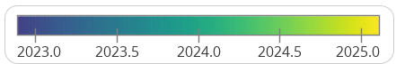

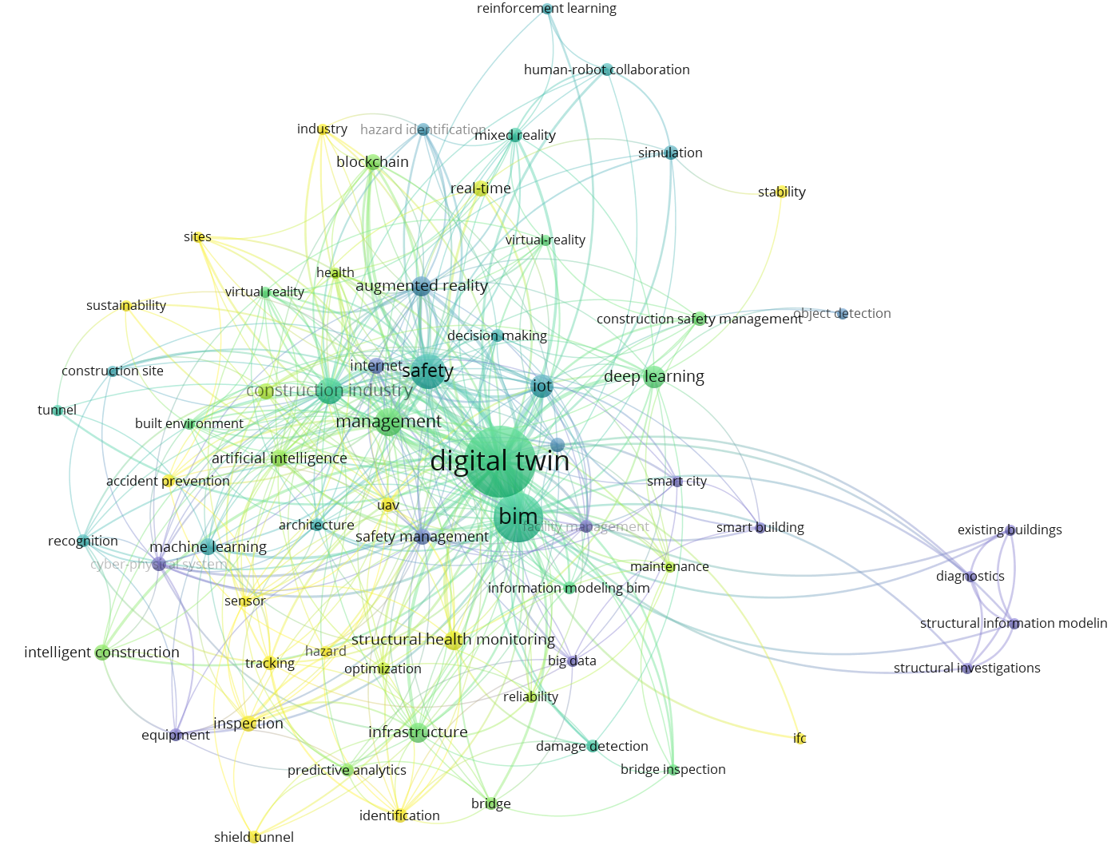
Figure 6 Overlay Visualization Themes (WoS)
The overlay visualization themes figure presents the keyword co-occurrence network of WoS, in which node colour encodes each keyword's average publication year. The colours concentrate narrowly between 2023 and 2025, mirroring the Scopus overlay and reflecting the corpus's pronounced skew toward recent years, whereby the sparse pre-2022 literature is numerically outweighed by the surge of 2024–2025 publications. The most recent thematic frontier (yellow, ≈2025) is anchored by reinforcement learning, object detection, damage detection, and predictive analytics, whereas foundational concepts such as cyber-physical system and machine learning register earlier average years (blue, ≈2023).
Besides, the peripheral orange cluster (existing buildings, diagnostics, structural investigations) sits far from the network core owing to its weak co-occurrence with the dominant hubs, marking condition diagnosis of existing structures as an as-yet unintegrated niche within the broader DT-in-AECO discourse.
In short, this compressed temporal range indicates that DT-in-AECO research addressing safety and quality is an exceptionally young, rapidly consolidating field whose intellectual base has yet to mature.
    - Keyword Co-occurrence map by WoS
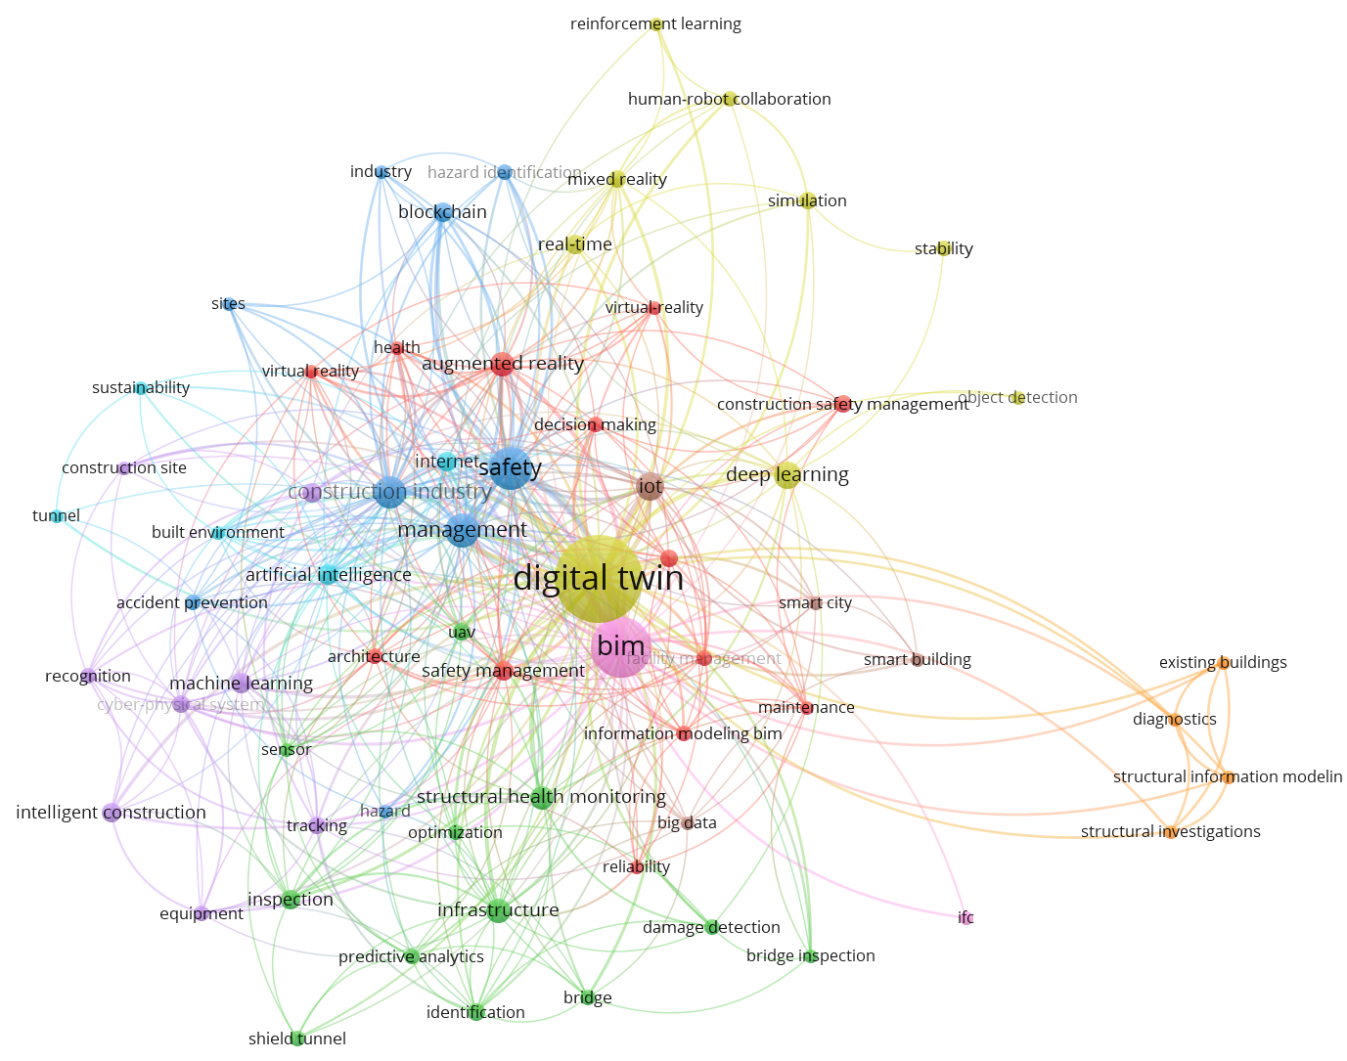
Figure 7 Keyword Co-occurrence Network (WoS)
The keyword co-occurrence network derived from the Web of Science subset, constructed with a minimum occurrence threshold of 3 yielding 66 retained keywords, reproduces the intellectual structure observed in the Scopus analysis. Digital twin again occupies the geometric centre with the highest link strength, flanked by BIM and safety as dual secondary hubs, and resolves into cognate thematic clusters spanning DT-AI sensing (reinforcement learning, deep learning, object detection), structural health monitoring and defect detection (damage detection, bridge inspection, infrastructure), risk-oriented safety management, and BIM-anchored decision support (augmented/virtual reality, decision making). Critically, the same diagnostic absence recurs: no keyword denoting cognitive digital twin, self-improving, self-learning, or convergence attains the occurrence threshold, while reinforcement learning remains peripheral and sparsely linked. This independent corpus thus confirms both the field's thematic organisation and the empirical scarcity of self-improving, convergence-aware DT formulations.
    - Co-citation Network Analysis by WoS
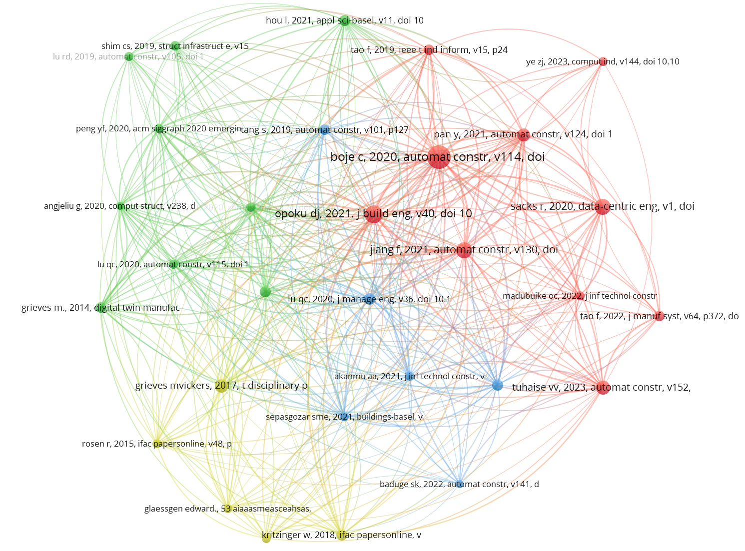
Figure 8 Co-citation network (WoS)
Document co-citation analysis of the Web of Science subset, applying a minimum threshold of 8 citations per cited reference and yielding 30 nodes, resolved the field's intellectual base into four coherent clusters.
The first (red) captures the construction-DT review and application front, anchored by the field's most central nodes including Boje, et al. [2], Girolami, et al. [24], Pan and Zhang [46] and Chen, et al. [33].
The second (green) comprises DT review and infrastructure-oriented applications Opoku, et al. [3] and Lu, et al. [47].
The third (blue) consolidates BIM and information-technology integration Sepasgozar, et al. [48] and Baduge, et al. [49].
The fourth (yellow) cluster assembles the paradigm's theoretical and manufacturing origins originated from Grieves and Vickers [1], Kritzinger, et al. [12], Stargel and Glaessgen [39], Bettenhausen, et al. [41]. The origins cluster occupies the network's lower periphery, which is spatially separated from the application-oriented core.
This structural detachment provides direct bibliometric evidence that the manufacturing-derived theoretical foundations of DT remain incompletely assimilated into AECO domain. Most consequentially, no co-cited foundation addressing self-improvement, autonomy, or convergence emerges in any cluster, confirming the same absence identified gap in the keyword analysis.
    - Cross database robustness alignment
The Scopus and WoS corpora are analysed independently and their keyword co-occurrence networks are compared as robustness check. Both of the two networks, generated from non-overlapping bibliographic sources, exhibit convergent structure comprising of an identical central hub of digital twin, the same dual secondary nodes of BIM and safety, and mutually consistent thematic clusters spanning AI-driven sensing, structural health monitoring, risk-oriented safety analytics and BIM decision support. This cross-database consistency indicates that the observed intellectual structure is a stable property of the field rather than an artefact of database coverage. Most consequentially, the absence of cognitive, self-improving, and convergence-related keywords is confirmed, substantially strengthens the identified research gap.

  - Thematic Synthesis
    - Digital Twin Capability Tiers in AECO
As shown in table 6, this paper encompasses 152 nos. relevant articles passing the selection criteria for detailed analysis. The 3-tier DT capability elaborated by Kritzinger, et al. [12] is further developed to include the higher 4th tier DT possessing the self-improving capability. The full text analysis confirms that none of the 152 nos. previous studies have achieved self-improving capability.

Table 6 Tier level of analyzed DT
Tier Level (Gap 1) | n | % of incl. | Reference
Tier 1 - Digital Model (static instead of live data) | 31 | 20.4% | [50-80]
Tier 2 - Digital Shadow (one-way data exchange) | 92 | 60.5% | [45, 81-171]
Tier 3 - Digital Twin (bidirectional data exchange) | 21 | 13.8% | [40, 172-191]
Tier 4 - Cognitive / Self-improving | 0 | 0.0%
Unclear | 8 | 5.3% | [192-199]
total | 152

Table 7 Design-for-X Applications
Category | n | % of incl. | Reference
DfS | 134 | 88.2% | Appendix A
DfQ) | 10 | 6.6% | [51, 55, 63, 69, 83, 97, 140, 158, 159, 170]
Both | 8 | 5.3% | [76, 85, 90, 91, 99, 192, 194, 199]
Total | 152

    - Self-Improving and Convergence-Aware Systems

Table 8 Data modality distributation
Category | n | % of incl. | Reference
Single data type | 16 | 10.5% | [54, 57, 66, 69, 75, 78, 84, 93, 98, 104, 111, 139, 180, 193] [62, 154]
Multiple data types | 136 | 89.5% | Appendix A
total | 152

Table 9 Self-Improving and Convergence distribution
Category | n | % of incl. | Ref.
None | 138 | 90.8% | Appendix A
Mentioned only | 10 | 6.6% | [58, 68, 76, 84, 111, 146, 172, 173, 175, 186]
Implemented | 4 | 2.6% | [87, 126, 134, 191]
Convergence-characterised | 0 | 0.0%
total | 152
There are 4 papers [87] [126] [134] [191] implemented self-improving mechanism which are closely in proximity of the convergence capability but not achieved. A review of these boundary cases confirms that, while each incorporates some form of learning or model updating, none satisfies the two defining criteria of Tier 4 of self-improving loop and a characterised convergence of the twin's own predictive model against realised project outcomes.
Chang, et al. [87] implement a DT framework for predicting ground-settlement and tunnel-lining deformation under adjacent excavation. Its hybrid surrogate model (DF-STTN, combining Swin Transformer + TabTransformer) is trained on over 1,000 finite element samples and includes an explicit "model updating" module for estimating soil parameters with a stated convergence threshold and demonstrated genetic algorithm (GA) convergence. It even reports generalisation to two unseen test configurations "without additional retraining." On paper, this is the closest any study comes to a self-improving, convergence-characterised twin. However, the tunnel DT possesses no Tier 4 capability due to four reasons. First, the reported convergence is a parameter-inversion optimiser, not the twin's own predictive model learning from realised outcomes. The GA convergence is a one-off back-analysis calibration and it searches for soil parameters that best fit laboratory dataset. This is classical inverse analysis, not the twin iteratively improving its cross-phase forecasts as a portfolio of real projects accumulates. The "convergence threshold" governs the GA's fitness instead of the convergence of the DT's design-to-outcome prediction error over time. Second, the updating is a closed, one-shot calibration against a scaled laboratory test, not a cross-project learning loop. Third, it does not link design decisions to realised performance outcomes. It predicts a physical field within one construction scenario. The prediction target is displacement magnitude, and as the author admitted one of the limitations of the model is that it does not explicitly capture time-dependent processes. There is no propagation from permanent design features to downstream across phases. The twin is single-phase without breaking barrier between design and construction. As such the convergence capability is unrealised. Fourth, the paper’s proposition of generalization without retraining is the opposite of self-improvement, which requires iterative training and learning. A Tier 4 twin would update on each new project.
Moe, et al. [126] propose a Federated Learning-based safety monitoring digital twin (FLSMDT) framework in which multiple edge devices with workers train local DNNs and a server iteratively aggregates with dynamic node selection to improve global-model convergence across communication rounds. However, there are three major gaps that define the FLSMDT as not tier 4. First, convergence of the framework here is FL training convergence of validation loss stabilising over 30 rounds, not convergence of the twin's predictions against realised safety incidents. The model converges on a 50,000-sample dataset. It is typical supervised regression of a safety index instead of a twin that improves by testing predictions against actual downstream outcomes. It proves that the FLSMDT is a virtualization and monitoring layer, not the self-improving learner. The paper explicitly positions DT as the "virtualization platform" for registration and synchronisation. The learning is FL and the twin itself does not update a predictive model of the asset. Second, the paper focuses on construction and explores no design linkage and therefore neither no validation of cross-phases for the self-improving design-to-outcome.
Shi, et al. [134] implement a stacking-ensemble surrogate model with an adaptive optimisation mechanism: virtual monitoring points compare predicted vs. actual displacement, and an error-driven strategy dynamically adjusts hyperparameters and re-weights samples to retrain the surrogate, reducing error from 20% to 5%. However, it is considered as tier 4 DT for three reasons. First, the "self-correction" is a one-off calibration of a surrogate against a numerical simulation, not an iterating loop that converges across successive real projects. Second, no convergence criterion of the twin's predictions is characterised. The prediction error reduction from 20% to 5% is for single case (Donglingxin landslide), reported as a static result, not a demonstrated convergence trajectory with a stopping rule. Third, the prediction target is displacement, not a design-to-safety/quality that link slope treatment design performance such as soil nailing, shotcrete, retraining structures.
Zhang, et al. [191] implement the most sophisticated learning case in the corpus. It combines PPO reinforcement learning, a Deep Neural Network-Proportional-Integral-Derivative (DNN-PID) controller, and transfer learning to migrate the controller to a physical scale model, where the hidden-to-output weights are updated online over 52 epochs during jacking tests. However, it is not categorized as tier 4 DT because the convergence implemented is of a control-loop, not of the digital twin's predictive model of the asset. What converges is the PID synchronisation error of four motors toward a setpoint not the twin learning to predict downstream safety/quality outcomes. The reported "convergence" of PPO reward stabilizing is controller tuning, not cross-phase forecast convergence. Besides, there is no design-stage feature propagates forward because the twin does not link permanent geometry to downstream performance index of safety or quality.

Table 10 Validation Level in methodology
Validation Levels | n | % of incl. | Ref
Conceptual only (no test) | 19 | 12.5% | Appendix A
Simulation | 16 | 10.5% | Appendix A
Lab / scale-model experiment | 5 | 3.3% | [40, 78, 108, 109, 160]
Single case study | 104 | 68.4% | Appendix A
Cross-project / multiple real projects | 8 | 5.3% | [50, 51, 63, 68, 73, 100, 162, 177]
total | 152

Table 11 Method distribution
Major methods | n | % of incl. | Ref
Computer Vision / CNN / object-detection | 25 | 16.4% | [45, 155, 160, 200]
Graph Neural Network (GNN) | 3 | 2.0% | [133, 136, 189]
LSTM / RNN (recurrent networks) | 2 | 1.3% | [147, 163]
Transformer / Large Language Model (LLM) | 7 | 4.6% | [87, 101, 151, 162, 176, 179, 195]
Reinforcement Learning (RL) | 2 | 1.3% | [96, 191]
Bayesian / probabilistic | 4 | 2.6% | [95, 118, 131] [186]
Agent-based model (ABM) | 1 | 0.7% | [57]
Finite Element Method / physics-based | 15 | 9.9% | [52, 58, 71, 86, 92, 108, 111, 116, 130, 132, 137, 184, 197, 201, 202]
Ontology / semantic | 9 | 5.9% | [60, 79, 109, 129, 138, 140, 174, 181, 194]
Statistical / change-point | 8 | 5.3% | [102, 113, 119, 124, 134, 165, 167, 169]
Digital Twin platform only without machine learning | 41 | 27.0% | [172] etc. Appendix A
Other / Mixed | 35 | 23.0% | Appendix A
total | 152

Table 12 Lifecycle phase coverage
Coverage | n | Ref
Design (any) | 5 | [59, 60, 99, 114, 192]
Construction (any) | 82 | [81, 83, 172] etc.
Operation (any) | 72 | [82, 172, 173] etc.
Single-phase | 147 | Refer to Appendix A
Multi-phase (cross-phase) | 5 | [99, 114, 115, 172, 192]
Total | 152

- Discussion
  - Summary of findings
This review combined bibliometric mapping with full-text thematic analysis to examine the development, current capabilities and methodological orientation of Digital Twin research addressing safety and quality in the Architecture, Engineering, Construction and Operations industry. The results reveal a rapidly expanding but still theoretically immature field. Publication output increased sharply after 2019, while the temporal keyword maps show that reinforcement learning, object detection, damage detection and predictive analytics have emerged only recently. The Scopus and Web of Science analyses produced broadly consistent thematic structures centred on Digital Twins, Building Information Modelling and safety, with related clusters covering automated sensing, structural health monitoring, risk assessment and decision support. However, terminology associated with cognitive capability, self-improvement and convergence remained absent or below the respective occurrence thresholds in both databases. This cross-database consistency indicates that the observed gaps are not attributable solely to the coverage of a particular database.
The full-text analysis further demonstrates a substantial difference between the claimed potential of Digital Twins and their realised capability. Among the 152 included studies, 31 were classified as Tier 1 Digital Models, 92 as Tier 2 Digital Shadows and 21 as Tier 3 bidirectional Digital Twins, while none reached Tier 4 Cognitive or Self-improving capability. The dominance of Tier 2 indicates that most existing systems support automated data transfer from physical assets to virtual representations but do not close the loop through continuous model adaptation. This interpretation is reinforced by the self-improvement assessment: 138 studies included no self-improvement mechanism, 10 mentioned the concept without implementation, only four implemented a limited updating mechanism, and none explicitly characterised convergence. The current research base therefore supports monitoring, visualisation and project-specific prediction more strongly than sustained learning across successive projects.
Safety constituted the principal application domain, with 134 studies addressing Design for Safety, compared with 10 addressing Design for Quality and eight addressing both. Nevertheless, this emphasis did not translate into strong design-stage integration. Only five studies covered the design phase, whereas 82 addressed construction and 72 addressed operation; 147 studies remained confined to a single lifecycle phase, and only five spanned multiple phases. Consequently, downstream safety incidents, defects and operational anomalies are commonly detected after they have materialised, while their relationships with originating design features remain insufficiently represented. Validation was similarly concentrated at the project level: 104 studies relied on a single case study, while only eight were evaluated across multiple real projects.
The findings also distinguish multimodal data availability from cognitive learning capability. Although 136 studies used two or more data types, multimodal integration was generally applied to improve sensing, representation or prediction within an individual application. It rarely supports cross-phase reasoning, transferable knowledge or iterative model improvement. Advanced approaches with potential to support these capabilities, including graph neural networks, large language models, reinforcement learning and Bayesian methods, remained sparsely represented in the reviewed corpus. Taken together, the results indicate that the principal limitation is no longer simply the availability of Building Information Modelling, sensor, image, point-cloud or textual data. The more fundamental limitation is the absence of an architecture that connects design features with downstream outcomes, retains learning across projects and evaluates whether successive model updates produce measurable improvement.
These findings provide the empirical basis for the unexplored areas and future directions presented in the following section. In particular, they point to the need for a Digital Twin that extends beyond real-time synchronisation by combining cross-phase prediction, multimodal reasoning, proxy-based model updating and cross-project convergence. These requirements subsequently inform the proposed Self-Improving Cognitive Digital Twin framework.
  - Research Gaps and future direction

Table 13 Research gaps and future directions for advancing Digital Twins towards self-improving cross-phase capability
No. | Research Gaps | Future Directions
1 | Absence of performance optimisation and convergence in cross-phase DT | - Develop convergence-aware, cross-project learning mechanisms.  - Prioritize self-supervised learning, unsupervised anomaly detection, case-based reasoning and Bayesian updating.
2 | Extensive multimodal data integration but limited multimodal reasoning with cross-phase knowledge transfer | - Integrate BIM geometry, images, point clouds, sensors and textual knowledge.  - Move from data fusion towards multimodal reasoning and model updating.
3 | lack of life-cycle integration from conceptual design | - Develop cross-phase models linking design decisions to construction and operational outcomes.  - Predict temporary-works, safety and quality risks before construction.
4 | Lack of unified Design for safety / quality predictor at element level | - Establish element-level relationships between design features and downstream risks.  - Integrate Design for Safety and Design for Quality within a semantic knowledge structure.
5 | Lack of empirical validation on real cross-project AECO data | - Validate models across multiple real projects records.  - Validate by leading-indicators, including near misses, safety costs, protection quantities, defects and rework.
The five gaps delineated above are not independent shortcomings but interrelated facets of a single structural absence of a mechanism by which a CDT understands integrated data and learns from realised outcomes and improves its own predictions over time. Addressing this absence requires a framework that simultaneously propagates risk forward from design to downstream phases while understanding the semantic data by reasoning. Most consequentially, iterative loop shall be closed to test predictions against real project outcomes and update the model until its error converges. These requirements collectively define the framework of the next generation of CDT as proposed below.

  - Toward a Self-Improving Cognitive Digital Twin
Based on the review results and analysis above, a next generation CDT framework is proposed for the cross-phases self-improving CDT in the AECO industry, as shown in Figure 9.
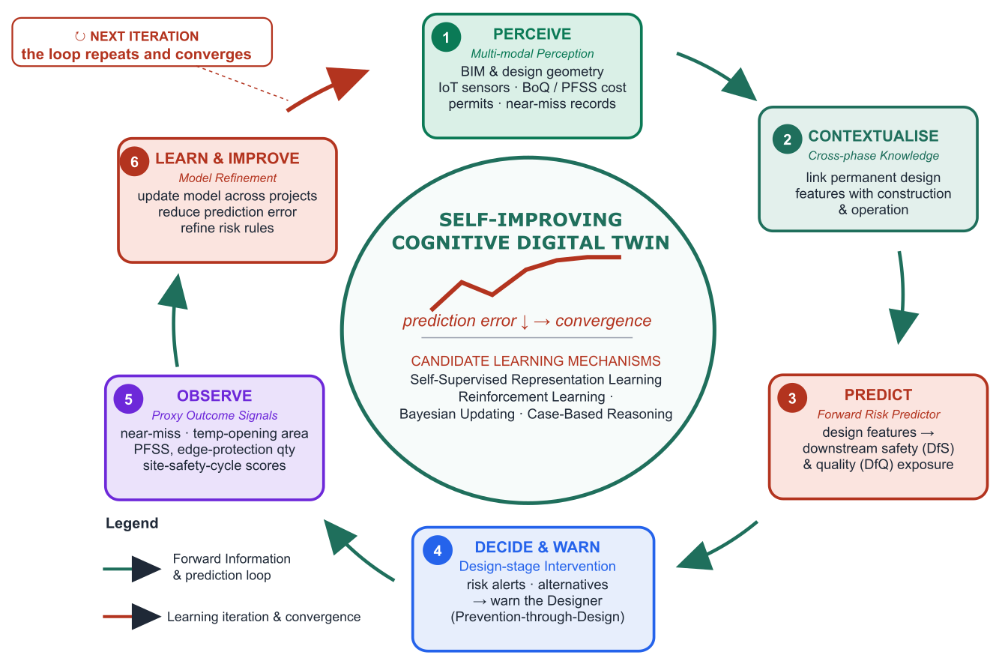
Figure 9 Proposed framework of self-improving cognitive digital twin

The CDT couples two objectives. First, a cross-phase forward predictor to forecast the performance of design by testing against the requirements in downstream safety and quality. Second, a cross-project convergence loop, which iteratively refines those predictions against leading indicators until convergence.

- Conclusions
This review set out to map the landscape of digital-twin research addressing design-for-safety and design-for-quality in the AECO sector, and to determine the extent to which existing systems exhibit self-improving, cross-phase, and convergence-aware capabilities. Four conclusions emerge. First, DT-in-AECO research has sharp growth since 2019 yet remains an exceptionally young field, as revealed by both keyword co-occurrence and co-citation analyses, because the knowledge graph has not yet consolidated into a mature canon. Second, the technologies are dominated by computer-vision and deep-learning techniques borrowed from adjacent domains of computer science. However, the approaches capable of supporting autonomous digital twin, including graph neural networks, large language models, reinforcement learning, agent-based modelling and their integration with DT, remain underexplored. Third, the overwhelming majority of DT implementations are limited to the digital-shadow and bidirectional-twin tiers, operate within a single lifecycle phase of O&M, and incorporate no mechanism by which the twin updates its own predictive model. Fourth, the review reveals the distinct theoretical, methodological, and empirical gap.
The central conclusion of this review is that, despite the widespread adoption of digital twins across the AECO industry, a self-improving, convergence-aware cognitive digital twin capable of cross-phase Design-for-X forecasting does not yet exist. This review thereby establishes both the necessity and the design requirements for the Self-Improving Cognitive Digital Twin.

Limitations of this study
- Database coverage: 2 sources only, i.e., Scopus and Web of Science,
- The restriction to English-language publications may potentially omitting relevant research published in other languages. Future reviews incorporating multilingual sources could provide a more comprehensive synthesis.
- DOI-indexed articles only
- Timeframe: 2015–2026
- VOSviewer clustering sensitivity to occurrence threshold

Declaration of Competing Interest
The authors declare that they have no known competing financial interests or personal relationships that could have appeared to influence the work reported in this paper.

Appendix A. Classification of the 152 Included Studies

References
Target words count: total 15,000, main body 10,000, reference 7,400 > 5,000

[1] M. Grieves and J. Vickers, "Digital Twin: Mitigating Unpredictable, Undesirable Emergent Behavior in Complex Systems," (in en), pp. 85-113, 2017 2017, doi: 10.1007/978-3-319-38756-7_4.
[2] C. Boje, A. Guerriero, S. Kubicki, and Y. Rezgui, "Towards a semantic Construction Digital Twin: Directions for future research," Automation in Construction, vol. 114, 2020, doi: 10.1016/j.autcon.2020.103179.
[3] D.-G. J. Opoku, S. Perera, R. Osei-Kyei, and M. Rashidi, "Digital twin application in the construction industry: A literature review," (in English), Journal of Building Engineering, vol. 40, Aug 2021, doi: 10.1016/j.jobe.2021.102726.
[4] T.-C. Kuo, S. H. Huang, and H.-C. Zhang, "Design for manufacture and design for ‘X’: concepts, applications, and perspectives," Computers & Industrial Engineering, vol. 41, no. 3, 2001/12/01, doi: 10.1016/S0360-8352(01)00045-6.
[5] A. Zhang, J. Yang, and F. Wang, "Application and enabling digital twin technologies in the operation and maintenance stage of the AEC industry: A literature review," (in English), Journal of Building Engineering, vol. 80, Dec 1 2023, doi: 10.1016/j.jobe.2023.107859.
[6] Q. Luo, C. Sun, Y. Li, Z. Qi, and G. Zhang, "Applications of digital twin technology in construction safety risk management: a literature review," Engineering, Construction and Architectural Management, vol. 32, no. 6, pp. 3587-3607, 2024/03/22 2024, doi: 10.1108/ecam-11-2023-1095.
[7] F. Tao, M. Zhang, Y. Liu, and A. Y. C. Nee, "Digital twin driven prognostics and health management for complex equipment," CIRP Annals, vol. 67, no. 1, 2018/01/01, doi: 10.1016/j.cirp.2018.04.055.
[8] D. Xu et al., "Design for safety (DfS) implementation in the construction industry: a study of design professionals in Northern China," Journal of Engineering, Design and Technology, vol. 24, no. 1, 2026/02/03, doi: 10.1108/JEDT-11-2024-0694.
[9] L. Kumi et al., "Development of Multimodal Recommender System for Advancing Design for Safety with Expert Validation," Journal of Construction Engineering and Management, vol. 151, no. 9, 2025-06-20, doi: 10.1061/JCEMD4.COENG-16802.
[10] S. Banihashemi, A. Assadimoghadam, A. Hajirasouli, K. LeNguyen, and S. R. Mohandes, "Parametric design in construction: a new paradigm for quality management and defect reduction," International Journal of Construction Management, vol. 25, no. 13, 2025-10-3, doi: 10.1080/15623599.2024.2447653.
[11] X.-R. Ni, P. Pan, and J.-R. Lin, "What makes a good BIM design? Quantifying the link between design behavior and quality," Automation in Construction, vol. 171, 2025/03/01, doi: 10.1016/j.autcon.2025.105992.
[12] W. Kritzinger, M. Karner, G. Traar, J. Henjes, and W. Sihn, "Digital Twin in manufacturing: A categorical literature review and classification," (in en-US), IFAC-PapersOnLine, vol. 51, no. 11, pp. 1016-1022, 2018 2018, doi: 10.1016/j.ifacol.2018.08.474.
[13] A. M. Madni, C. C. Madni, and S. D. Lucero, "Leveraging Digital Twin Technology in Model-Based Systems Engineering," Systems, vol. 7, no. 1, 2019, doi: 10.3390/systems7010007.
[14] Arup, "Digital Twin Towards A Meaningful Framework," 2019.
[15] Y. Zheng, S. Yang, and H. Cheng, "An application framework of digital twin and its case study," Journal of Ambient Intelligence and Humanized Computing 2018 10:3, vol. 10, no. 3, 2018-06-18, doi: 10.1007/s12652-018-0911-3.
[16] J. M. Schooling, Q. C. Lu, X. Xie, and A. K. Parlikad, "Digital twin-enabled anomaly detection for built asset monitoring in operation and maintenance," (in English), Automation in Construction, vol. 118, Oct 2020, doi: 10.1016/j.autcon.2020.103277.
[17] E. A. Pärn, D. J. Edwards, and M. C. P. Sing, "The building information modelling trajectory in facilities management: A review," Automation in Construction, vol. 75, 2017/03/01, doi: 10.1016/j.autcon.2016.12.003.
[18] G. Marzi, M. Balzano, A. Caputo, and M. M. Pellegrini, "Guidelines for Bibliometric‐Systematic Literature Reviews: 10 steps to combine analysis, synthesis and theory development," International Journal of Management Reviews, vol. 27, no. 1, 2025/01/01, doi: 10.1111/ijmr.12381.
[19] M. J. Page et al., "The PRISMA 2020 statement: an updated guideline for reporting systematic reviews," (in en), BMJ, p. n71, 2021/03/29/ 2021, doi: 10.1136/bmj.n71.
[20] N. J. van Eck and L. Waltman, "Citation-based clustering of publications using CitNetExplorer and VOSviewer," Scientometrics 2017 111:2, vol. 111, no. 2, 2017-02-27, doi: 10.1007/s11192-017-2300-7.
[21] M. Grieves, "Digital Twin: Manufacturing Excellence through Virtual Factory Replication," 2014.
[22] C. Barlow, A. Fuller, Z. Fan, and C. Day, "Digital Twin: Enabling Technologies, Challenges and Open Research," (in English), Ieee Access, vol. 8, pp. 108952-108971, 2020, doi: 10.1109/Access.2020.2998358.
[23] C. M. Flath, T. Greif, and N. Stein, "Peeking into the void: Digital twins for construction site logistics," (in English), Computers in Industry, vol. 121, Oct 2020, doi: 10.1016/j.compind.2020.103264.
[24] M. Girolami, R. Sacks, I. Brilakis, E. Pikas, and H. S. Xie, "Construction with digital twin information systems," (in en), DCE, vol. 1, p. e14, 2020 2020, doi: 10.1017/dce.2020.16.
[25] S. H. KHAJAVI;, N. H. M. ;, A. JARIBION;, L. C. WERNER;, and J. HOLMSTRÖM, "Digital Twin: Vision, Benefits, Boundaries, and Creation for Buildings," IEEE Access, vol. 7, 2019, doi: 10.1109/ACCESS.2019.2946515.
[26] A. RASHEED, O. SAN, and T. KVAMSDAL, "Digital Twin: Values, Challenges and Enablers From a Modeling Perspective," (in en-US), IEEE Access, vol. 8, pp. 21980-22012, 2020 2020, doi: 10.1109/access.2020.2970143.
[27] D. Jones, C. Snider, A. Nassehi, J. Yon, and B. Hicks, "Characterising the Digital Twin: A systematic literature review," (in en-US), CIRP Journal of Manufacturing Science and Technology, vol. 29, pp. 36-52, 2020/05/01/ 2020, doi: 10.1016/j.cirpj.2020.02.002.
[28] M. W. Grieves, "Product lifecycle management: the new paradigm for enterprises," 2005.
[29] R. S. Sutton and A. G. Barto, Reinforcement Learning: An Introduction. 2015.
[30] H. Yue, Q. Wang, M. Zhao, Z. Yang, and L. Lu, "Advancements in Digital Twin Applications for Intelligent Construction Quality Management," Journal of Construction Engineering and Management, vol. 152, no. 1, 2026, doi: 10.1061/jcemd4.coeng-17126.
[31] M. Zhang, T. Fei, F. Tao, and Z. Meng, "Digital Twin Shop-Floor: A New Shop-Floor Paradigm Towards Smart Manufacturing," (in en-US), IEEE Access, vol. 5, pp. 20418-20427, 2017/09/26/ 2017, doi: 10.1109/ACCESS.2017.2756069.
[32] V. R. Kamat, M. Deng, and C. C. Menassa, "From BIM to digital twins: A systematic review of the evolution of intelligent building representations in the AEC-FM industry," (in en), Journal of Information Technology in Construction, vol. 26, pp. 58-83, 2021/02/03/ 2021, doi: 10.36680/j.itcon.2021.005.
[33] K. Chen, F. Jiang, L. Ma, and T. Broyd, "Digital twin and its implementations in the civil engineering sector," (in en), Automation in Construction, vol. 130, p. 103838, 2021/10// 2021, doi: 10.1016/j.autcon.2021.103838.
[34] F. Tao, Q. Qinglin, Q. Qi, and T. Fei, "Digital Twin and Big Data Towards Smart Manufacturing and Industry 4.0: 360 Degree Comparison," (in en-US), IEEE Access, vol. 6, pp. 3585-3593, 2018/01/15/ 2018, doi: 10.1109/access.2018.2793265.
[35] Girshick Ross, Shaoqing Ren, Kaiming He, and J. Sun, "Faster R-CNN Towards Real-Time Object Detection with Region Proposal Networks."
[36] M. Kassem, S. Muhammad, S. Muhammad Tariq, and D. Dean, "Digital twins in built environments: An investigation of the characteristics, applications, and challenges," (in en), Buildings, vol. 12, no. 2, pp. 120-120, 2022/01/25/ 2022, doi: 10.3390/buildings12020120.
[37] G. B. Ozturk, "Digital Twin Research in the AECO-FM Industry," (in English), Journal of Building Engineering, vol. 40, Aug 2021, doi: ARTN 102730 10.1016/j.jobe.2021.102730.
[38] C. Taylor et al., "Towards Civil Engineering 4.0: Concept, workflow and application of Digital Twins for existing infrastructure," (in English), Automation in Construction, vol. 141, Sep 2022, doi: ARTN 104421 10.1016/j.autcon.2022.104421.
[39] D. Stargel and E. Glaessgen, "The Digital Twin Paradigm for Future NASA and U.S. Air Force Vehicles," presented at the 53rd AIAA/ASME/ASCE/AHS/ASC Structures, Structural Dynamics and Materials Conference<BR>20th AIAA/ASME/AHS Adaptive Structures Conference<BR>14th AIAA, 2012.
[40] C. Huang, Z. Liu, G. Shi, and A. Zhang, "Intelligent tensioning method for prestressed cables based on digital twins and artificial intelligence," (in English), Sensors, Article vol. 20, no. 24, pp. 1-20, 2020, Art no. 7006, doi: 10.3390/s20247006.
[41] K. D. Bettenhausen, R. Rosen, G. Von Wichert, and G. Lo, "About The Importance of Autonomy and Digital Twins for the Future of Manufacturing," IFAC-PapersOnLine, vol. 48, no. 3, pp. 567-572, 2015 2015, doi: 10.1016/j.ifacol.2015.06.141.
[42] O. Phil-Ebosie et al., "Digital Twin Aided Vulnerability Assessment and Risk-Based Maintenance Planning of Bridge Infrastructures Exposed to Extreme Conditions," Sustainability 2021, Vol. 13, Page 2051, vol. 13, no. 4, 2021-02-14, doi: 10.3390/su13042051.
[43] M. Zhang, F. Tao, W. Liu, and Q. Qi, "Five-dimension Digital Twin Model and its Ten Applications," 2019, doi: 10.13196/j.cims.2019.01.002.
[44] C. Xu, M. Liu, S. Fang, and H. Dong, "Review of digital twin about concepts, technologies, and industrial applications," (in en), Journal of Manufacturing Systems, vol. 58, pp. 346-361, 2021/01/01/ 2021, doi: 10.1016/j.jmsy.2020.06.017.
[45] B. F. Spencer and N. M. Levine, "Post-Earthquake Building Evaluation Using UAVs: A BIM-Based Digital Twin Framework," (in English), Sensors, Article vol. 22, no. 3, 2022, Art no. 873, doi: 10.3390/s22030873.
[46] Y. Pan and L. M. Zhang, "A BIM-data mining integrated digital twin framework for advanced project management," (in English), Automation in Construction, vol. 124, Apr 2021, doi: ARTN 103564 10.1016/j.autcon.2021.103564.
[47] Q. C. Lu et al., "Developing a Digital Twin at Building and City Levels: Case Study of West Cambridge Campus," (in English), Journal of Management in Engineering, vol. 36, no. 3, May 1 2020, doi: Artn 05020004 10.1061/(Asce)Me.1943-5479.0000763.
[48] S. M. E. Sepasgozar, M. Ghobadi, S. Shirowzhan, D. J. Edwards, and E. Delzendeh, "Metrics development and modelling the mixed reality and digital twin adoption in the context of Industry 4.0," (in English), ENGINEERING CONSTRUCTION AND ARCHITECTURAL MANAGEMENT, vol. 28, no. 5, pp. 1355-1376, JUN 10 2021, doi: 10.1108/ECAM-10-2020-0880.
[49] S. K. Baduge et al., "Artificial intelligence and smart vision for building and construction 4.0: Machine and deep learning methods and applications," Automation in Construction, vol. 141, 2022, doi: 10.1016/j.autcon.2022.104440.
[50] A. Aragón et al., "Seeking a Definition of Digital Twins for Construction and Infrastructure Management," (in English), Appl. Sci., Article vol. 15, no. 3, 2025, Art no. 1557, doi: 10.3390/app15031557.
[51] Y. Arhrib, F. Alvarez-Taboada, and H. Boulaassal, "Serverless 3D Reconstruction and Spatial Anchoring for Cloud-Native Infrastructure Inspection," (in English), Buildings, Article vol. 16, no. 12, 2026, Art no. 2433, doi: 10.3390/buildings16122433.
[52] H. Aroquipa, A. Hurtado, and C. Angel, "Methodological framework for integrating structural health monitoring and digital-twin models for seismic assessment of heritage buildings: Case study of Basilica Maria Auxiliadora, Lima, Peru," (in English), STRUCTURES, vol. 80, OCT 2025, Art no. 110115, doi: 10.1016/j.istruc.2025.110115.
[53] E. Brucherseifer, H. Winter, A. Mentges, M. Mühlhäuser, and M. Hellmann, "Digital Twin conceptual framework for improving critical infrastructure resilience," (in English), At-Automatisierungstechnik, Article vol. 69, no. 12, pp. 1062-1080, 2021, doi: 10.1515/auto-2021-0104.
[54] J. Cervenka, Z. Janda, J. Kovar, R. Marik, and V. Drahy, "AI based surrogate model for digital twins in structural health monitoring of reinforced concrete structures," (in English), J Struct Eng, Article vol. 52, no. 5-6, pp. 408-423, 2026. [Online]. Available: https://www.scopus.com/pages/publications/105042626265?origin=resultslist.
[55] C. C. Chang, T. W. Huang, Y. H. Chen, J. J. Lin, and C. S. Chen, "Autonomous dimensional inspection and issue tracking of rebar using semantically enriched 3D models," (in English), AUTOMATION IN CONSTRUCTION, vol. 160, APR 2024, Art no. 105303, doi: 10.1016/j.autcon.2024.105303.
[56] H. R. Deng, H. J. Li, L. Q. Xu, A. Khudhair, H. H. Song, and Y. Gao, "Real-time bridge disaster management: Enabling technology and application framework," (in English), AUTOMATION IN CONSTRUCTION, vol. 174, JUN 2025, Art no. 106150, doi: 10.1016/j.autcon.2025.106150.
[57] Q. Fang, X. C. Chen, D. Castro-Lacouture, and C. Q. Li, "Intervention and management of construction workers' unsafe behavior: A simulation digital twin model," (in English), ADVANCED ENGINEERING INFORMATICS, vol. 58, OCT 2023, Art no. 102182, doi: 10.1016/j.aei.2023.102182.
[58] M. Granzner, A. Strauss, M. Reiterer, M. S. Cao, and D. Novák, "Data-Driven Condition Assessment and Life Cycle Analysis Methods for Dynamically and Fatigue-Loaded Railway Infrastructure Components," (in English), INFRASTRUCTURES, vol. 8, no. 11, NOV 2023, Art no. 162, doi: 10.3390/infrastructures8110162.
[59] F. Jiang, L. Ma, T. Broyd, K. Chen, and H. B. Luo, "Underpass clearance checking in highway widening projects using digital twins," (in English), AUTOMATION IN CONSTRUCTION, vol. 141, SEP 2022, Art no. 104406, doi: 10.1016/j.autcon.2022.104406.
[60] K. W. Johansen, C. Schultz, and J. Teizer, "Knowledge graph exploitation to enhance the usability of risk assessment in construction safety planning," (in English), ADVANCED ENGINEERING INFORMATICS, vol. 65, MAY 2025, Art no. 103305, doi: 10.1016/j.aei.2025.103305.
[61] M. Kamari and Y. Ham, "AI-based risk assessment for construction site disaster preparedness through deep learning-based digital twinning," (in English), AUTOMATION IN CONSTRUCTION, vol. 134, FEB 2022, Art no. 104091, doi: 10.1016/j.autcon.2021.104091.
[62] N. Kang, S. W. Seo, W. S. Jung, J. Lee, and Y. T. Lee, "Effective Underground Facilities Management in Virtual Reality by Applying a Cybersickness Reduction Technique Based on a Four-Degree-of-Freedom Motion Simulator," (in English), IEEE Access, Article vol. 13, pp. 19598-19611, 2025, doi: 10.1109/ACCESS.2025.3532597.
[63] J. Li, B. Tao, F. Bosché, C. X. Lu, and L. Wilson, "Automated generation and semantic segmentation of roof orthophoto for digital twin -based monitoring of slated roofs," (in English), Automation in Construction, Article vol. 167, 2024, Art no. 105725, doi: 10.1016/j.autcon.2024.105725.
[64] M. Li, X. Feng, and Q. Hu, "3D laser point cloud-based geometric digital twin for condition assessment of large diameter pipelines," (in English), Tunnelling and Underground Space Technology, Article vol. 142, 2023, Art no. 105430, doi: 10.1016/j.tust.2023.105430.
[65] F. Luleci, A. Sevim, E. E. Ozguven, and F. N. Catbas, "Community Twin Ecosystem for Disaster Resilient Communities," (in English), Smart. Cities., Article vol. 7, no. 6, pp. 3511-3546, 2024, doi: 10.3390/smartcities7060137.
[66] Y. H. Lv et al., "Automating digitalization of engineered slopes to support interactive digital twin visualization," (in English), AUTOMATION IN CONSTRUCTION, vol. 181, JAN 2026, Art no. 106564, doi: 10.1016/j.autcon.2025.106564.
[67] L. B. Machado, B. L. Poncetti, L. S. de Assis, and M. M. Futai, "Automated procedural modeling for tunnel inspection and digital twin development," (in English), TUNNELLING AND UNDERGROUND SPACE TECHNOLOGY, vol. 165, NOV 2025, Art no. 106929, doi: 10.1016/j.tust.2025.106929.
[68] S. Meschini et al., "Toward cognitive digital twins using a BIM-GIS asset management system for a diffused university," (in English), Frontiers in Built Environment, Article vol. 8, 2022, Art no. 959475, doi: 10.3389/fbuil.2022.959475.
[69] T. F. Okuntade and O. Abisuga, "Construction defects, envelope degradation and lifecycle carbon implications for building energy performance: evidence from Lagos, Nigeria," (in English), ENERGY AND BUILDINGS, vol. 367, SEP 15 2026, Art no. 117751, doi: 10.1016/j.enbuild.2026.117751.
[70] Y. D. Pan, A. Braun, and I. Brilakis, "Enriching geometric digital twins of buildings with small objects by fusing laser scanning and AI-based image recognition," (in English), AUTOMATION IN CONSTRUCTION, vol. 140, AUG 2022, Art no. 104375, doi: 10.1016/j.autcon.2022.104375.
[71] F. C. Ponzo, G. Auletta, P. Ielpo, and R. Ditommaso, "DInSAR–SBAS satellite monitoring of infrastructures: how temperature affects the “Ponte della Musica” case study," (in English), Journal of Civil Structural Health Monitoring, Article vol. 14, no. 3, pp. 745-761, 2024, doi: 10.1007/s13349-023-00751-z.
[72] T. Salem and M. Dragomir, "Digital Twins for Construction Projects—Developing a Risk Systematization Approach to Facilitate Anomaly Detection in Smart Buildings," (in English), Telecom., Article vol. 4, no. 1, pp. 135-145, 2023, doi: 10.3390/telecom4010009.
[73] V. Scolamiero and P. Boccardo, "A BIM-Based Digital Twin Framework for Urban Roads: Integrating MMS and Municipal Geospatial Data for AI-Ready Urban Infrastructure Management," (in English), Sensors, Article vol. 26, no. 3, 2026, Art no. 947, doi: 10.3390/s26030947.
[74] W. J. Shen, C. Wang, C. Zhu, D. F. Wang, and Z. B. Chen, "Reverse digital twin mapping of building envelope anomalies based on UAV infrared point clouds," (in English), MEASUREMENT, vol. 258, JAN 30 2026, Art no. 119256, doi: 10.1016/j.measurement.2025.119256.
[75] Z. Song, H. Shi, X. Bai, and G. Li, "Digital twin-assisted fault diagnosis system for robot joints with insufficient data," (in English), J. Field. Rob., Article vol. 40, no. 2, pp. 258-271, 2023, doi: 10.1002/rob.22127.
[76] J. Torres, R. San-Mateos, N. Lasarte, A. Mediavilla, M. Sagarna, and I. León, "Building Digital Twins to Overcome Digitalization Barriers for Automating Construction Site Management," (in English), BUILDINGS, vol. 14, no. 7, JUL 2024, Art no. 2238, doi: 10.3390/buildings14072238.
[77] J. Wang, Y. Wu, S. Wang, Y. Narazaki, H. Liu, and B. F. Spencer, "Development and validation of graphics‐based digital twin framework for UAV‐aided post‐earthquake inspection of high‐rise buildings," The Structural Design of Tall and Special Buildings, vol. 33, no. 13, 2024/05/09 2024, doi: 10.1002/tal.2127.
[78] A. L. Zhang, J. Wang, Y. X. Zhang, and G. H. Shangguan, "Joint detection PCD-based method for automatic construction of geometric digital twin in cable dome structure," (in English), ENGINEERING STRUCTURES, vol. 320, DEC 1 2024, Art no. 118908, doi: 10.1016/j.engstruct.2024.118908.
[79] Y. H. Zhang, Y. M. Zhao, Z. Y. Li, W. He, and Y. Liu, "Research on the Digital Twin System for Rotation Construction Monitoring of Cable-Stayed Bridge Based on MBSE," (in English), BUILDINGS, vol. 15, no. 9, APR 28 2025, Art no. 1492, doi: 10.3390/buildings15091492.
[80] M. Kamari, J. Kim, and Y. Ham, "Analyzing Safety Risk Imposed by Jobsite Debris to Nearby Built Environments Using Geometric Digital Twins and Vision-Based Deep Learning," (in English), Journal of Computing in Civil Engineering, Article vol. 36, no. 6, 2022, Art no. 04022033, doi: 10.1061/(ASCE)CP.1943-5487.0001044.
[81] M. U. Ahmad et al., "Lessons Learned from the Real-World Deployment of Multisensor Fusion for Proactive Work Zone Safety Application," (in English), Transportation Research Record, Article 2026, doi: 10.1177/03611981261441281.
[82] M. D. Álvaro, R. Novak, P. R. F. Barbosa, I. C. Capelo, M. Gallego, and M. C. Rodriguez-Sanchez, "GUIDE2FR: A smart monitoring platform with a digital twin of a firefighter training tower for emergency scenarios," (in English), Internet. Thing., Article vol. 34, 2025, Art no. 101768, doi: 10.1016/j.iot.2025.101768.
[83] C. S. Araújo, F. R. Corrêa, E. D. M. Ferreira, and D. B. Costa, "Proposal of a conceptual model of digital twins for construction sites," (in English), REVISTA INGENIERIA DE CONSTRUCCION, vol. 40, DEC 2025, Art no. 21, doi: 10.7764/RIC.00168.21.
[84] A. Armijo and D. Zamora-Sánchez, "Integration of Railway Bridge Structural Health Monitoring into the Internet of Things with a Digital Twin: A Case Study," (in English), Sensors, Article vol. 24, no. 7, 2024, Art no. 2115, doi: 10.3390/s24072115.
[85] R. Chacón et al., "Digital twinning of building construction processes. Case study: A reinforced concrete cast-in structure," (in English), JOURNAL OF BUILDING ENGINEERING, vol. 84, MAY 1 2024, Art no. 108522, doi: 10.1016/j.jobe.2024.108522.
[86] R. W. K. Chan and T. Iwata, "Risk Mitigation of a Heritage Bridge Using Noninvasive Sensors," (in English), Sensors, Article vol. 25, no. 12, 2025, Art no. 3727, doi: 10.3390/s25123727.
[87] X. Y. Chang, H. Y. Fan, Y. G. Fu, C. J. Han, H. Wang, and J. X. Mao, "A transformer-based surrogate modeling strategy for tunnel digital twin in full-field displacement prediction under adjacent tunnel construction," (in English), ADVANCED ENGINEERING INFORMATICS, vol. 69, JAN 2026, Art no. 104045, doi: 10.1016/j.aei.2025.104045.
[88] D. Dan, Y. Ying, and L. Ge, "Digital Twin System of Bridges Group Based on Machine Vision Fusion Monitoring of Bridge Traffic Load," (in English), IEEE Transactions on Intelligent Transportation Systems, Article vol. 23, no. 11, pp. 22190-22205, 2022, doi: 10.1109/TITS.2021.3130025.
[89] R. Delhibabu, N. Zhukova, and A. Subbotin, "Interconnected digital twins of subway stations for decision support systems," (in English), Results in Engineering, Article vol. 30, 2026, Art no. 110745, doi: 10.1016/j.rineng.2026.110745.
[90] B. Deng, A. Osmadi, and Y. H. Deng, "Structural Analysis of Construction Risk Management Assessment Model Based on Digital Twins," (in English), JOURNAL OF CONSTRUCTION IN DEVELOPING COUNTRIES, vol. 30, pp. 217-238, 2025, doi: 10.21315/jcdc.2025.30.s2.10.
[91] O. Doukari, T. Bacnak, and E. Mahamedi, "Stakeholder-informed renovation digital twin for multi-domain monitoring: Pilot implementation and acceptance evaluation," (in English), Energy and Buildings, Article vol. 354, 2026, Art no. 116979, doi: 10.1016/j.enbuild.2026.116979.
[92] M. Franciosi, M. Kasser, and M. Viviani, "Digital twins in bridge engineering for streamlined maintenance and enhanced sustainability," (in English), Automation in Construction, Article vol. 168, 2024, Art no. 105834, doi: 10.1016/j.autcon.2024.105834.
[93] L. Gao and S. Chen, "Digital twin-based vibration displacement sensing and recognition technology for large engineering structures," (in English), Archives of Civil Engineering, Article vol. 71, no. 4, pp. 425-437, 2025, doi: 10.24425/ace.2025.156179.
[94] Y. Gao, G. Y. Xiong, Z. Y. Hu, C. Z. Chai, and H. J. Li, "Bridge Digital Twin for Practical Bridge Operation and Maintenance by Integrating GIS and BIM," (in English), BUILDINGS, vol. 14, no. 12, DEC 2024, Art no. 3731, doi: 10.3390/buildings14123731.
[95] Z. H. Geng, C. Zhang, Y. S. Jiang, D. Pugliese, and M. H. Cheng, "Integrating multi-source data for life-cycle risk assessment of bridge networks: a system digital twin framework," (in English), JOURNAL OF INFRASTRUCTURE PRESERVATION AND RESILIENCE, vol. 6, no. 1, FEB 27 2025, Art no. 9, doi: 10.1186/s43065-025-00121-7.
[96] J. Gu, J. Wang, X. Guo, G. Liu, S. Qin, and Z. Bi, "A Metaverse-Based Teaching Building Evacuation Training System With Deep Reinforcement Learning," (in English), IEEE Trans. Syst. Man Cybern. Syst., Article vol. 53, no. 4, pp. 2209-2219, 2023, doi: 10.1109/TSMC.2022.3231299.
[97] M. Guo et al., "A methodology for sky-space-ground integrated remote sensing monitoring: A digital twin framework for multi-source Data-BIM integration in residential quality monitoring," (in English), JOURNAL OF BUILDING ENGINEERING, vol. 102, MAY 15 2025, Art no. 111976, doi: 10.1016/j.jobe.2025.111976.
[98] Y. Ham and J. Kim, "Participatory Sensing and Digital Twin City: Updating Virtual City Models for Enhanced Risk-Informed Decision-Making," (in English), Journal of Management in Engineering, Article vol. 36, no. 3, 2020, Art no. 04020005, doi: 10.1061/(ASCE)ME.1943-5479.0000748.
[99] F. Han and Y. J. An, "Construction Path of Shanghai Oriental Hub Municipal Pipeline Full Cycle Digital Twin Platform," (in English), ADVANCES IN CIVIL ENGINEERING, vol. 2026, no. 1, 2026, Art no. 8916300, doi: 10.1155/adce/8916300.
[100] M. Q. Han, J. H. Zhang, Y. J. Huang, J. W. Xu, X. Chen, and B. M. Chen, "Enhancing worker monitoring and management on large-scale construction sites with UAVs and digital twin modeling," (in English), AUTOMATION IN CONSTRUCTION, vol. 174, JUN 2025, Art no. 106108, doi: 10.1016/j.autcon.2025.106108.
[101] Y. Han, K. Sun, Z. Zhao, Y. Yu, and G. Q. Huang, "Digital twin-driven pose estimation and trajectory prediction for modular integrated construction on-site stacking via spatio-temporal feature fusion modeling," (in English), Computers in Industry, Article vol. 180, 2026, Art no. 104501, doi: 10.1016/j.compind.2026.104501.
[102] A. Hekmatnejad et al., "Toward intelligent tunnel construction: The universal discontinuity index for rapid probabilistic prediction of progressive batch rock-block failure—A theoretical, numerical, and experimental validation framework," (in English), Tunnelling and Underground Space Technology, Article vol. 166, 2025, Art no. 107017, doi: 10.1016/j.tust.2025.107017.
[103] C. Hong, J. Zhang, and W. Chen, "An Integrated Intelligent Approach for Monitoring and Management of a Deep Foundation Pit in a Subway Station," (in English), Sensors, Article vol. 22, no. 22, 2022, Art no. 8737, doi: 10.3390/s22228737.
[104] K. P. Hong and J. Teizer, "Digital construction site layout planning and real-time trajectory analysis for proactive safety monitoring and control of struck-by hazards," (in English), AUTOMATION IN CONSTRUCTION, vol. 177, SEP 2025, Art no. 106353, doi: 10.1016/j.autcon.2025.106353.
[105] X. Hu, G. Olgun, and R. H. Assaad, "An intelligent BIM-enabled digital twin framework for real-time structural health monitoring using wireless IoT sensing, digital signal processing, and structural analysis," (in English), Expert Systems with Applications, Article vol. 252, 2024, Art no. 124204, doi: 10.1016/j.eswa.2024.124204.
[106] C. Huang, L. Wan, G. Shi, H. Sun, J. Wang, and C. Zhang, "Research on an intelligent monitoring system for the entire tunnel construction process based on IoT and digital twin," (in English), International Journal of Metrology and Quality Engineering, Article vol. 17, 2026, Art no. 4, doi: 10.1051/ijmqe/2025014.
[107] H. Jiang and A. Jiang, "Monitoring System for the Construction of Arch Cover Method Subway Station Based on DT and IoT," (in English), J. Sensors, Article vol. 2022, 2022, Art no. 1875196, doi: 10.1155/2022/1875196.
[108] W. Jiang, L. Ding, and C. Zhou, "Digital twin: Stability analysis for tower crane hoisting safety with a scale model," (in English), Automation in Construction, Article vol. 138, 2022, Art no. 104257, doi: 10.1016/j.autcon.2022.104257.
[109] W. Jiang, Y. Liu, K. Chen, Y. Liu, and L. Ding, "Early-warning of unsafe hoisting operations: An integration of digital twin and knowledge graph," (in English), Developments in the Built Environment, Article vol. 19, 2024, Art no. 100490, doi: 10.1016/j.dibe.2024.100490.
[110] S. H. Khajavi, M. Tetik, Z. Liu, P. Korhonen, and J. Holmstrom, "Digital Twin for Safety and Security: Perspectives on Building Lifecycle," (in English), IEEE Access, Article vol. 11, pp. 52339-52356, 2023, doi: 10.1109/ACCESS.2023.3278267.
[111] D. Kim, G. Kim, S. Kwag, and S. Eem, "Constructing a digital twin for estimating the response and load of a piping system subjected to seismic and arbitrary loads," (in English), SMART STRUCTURES AND SYSTEMS, vol. 31, no. 3, pp. 275-281, MAR 2023, doi: 10.12989/sss.2023.31.3.275.
[112] Y. Kim and Y. Ham, "Spatio-temporal heat risk analysis in construction: Digital twin-enabled monitoring," (in English), AUTOMATION IN CONSTRUCTION, vol. 168, DEC 1 2024, Art no. 105805, doi: 10.1016/j.autcon.2024.105805.
[113] Y. J. Kim, H. Kim, B. Ha, and W. T. Kim, "Advanced fire emergency management based on potential fire risk assessment with informative digital twins," (in English), AUTOMATION IN CONSTRUCTION, vol. 167, NOV 2024, Art no. 105722, doi: 10.1016/j.autcon.2024.105722.
[114] X. Lai, X. He, S. Wang, X. Wang, W. Sun, and X. Song, "Building a Lightweight Digital Twin of a Crane Boom for Structural Safety Monitoring Based on a Multifidelity Surrogate Model," (in English), J Mech Des, Article vol. 144, no. 6, 2022, Art no. 064502, doi: 10.1115/1.4053606.
[115] M. C. Li, Q. R. Lu, S. Bai, M. X. Zhang, H. J. Tian, and L. Qin, "Digital twin-driven virtual sensor approach for safe construction operations of trailing suction hopper dredger," (in English), AUTOMATION IN CONSTRUCTION, vol. 132, DEC 2021, Art no. 103961, doi: 10.1016/j.autcon.2021.103961.
[116] S. W. Lin, L. P. Duan, J. M. Liu, J. Miao, H. M. Li, and J. C. Zhao, "Creation and application of a geometric digital twin model for construction of spatial cable structures: A case study," (in English), ENGINEERING STRUCTURE AND CIVIL ENGINEERING, vol. 20, no. 5, pp. 992-1010, MAY 2026, doi: 10.1007/s11709-026-1301-0.
[117] Y. C. Lin and W. F. Cheung, "Developing WSN/BIM-Based Environmental Monitoring Management System for Parking Garages in Smart Cities," (in English), JOURNAL OF MANAGEMENT IN ENGINEERING, vol. 36, no. 3, MAY 1 2020, Art no. 04020012, doi: 10.1061/(ASCE)ME.1943-5479.0000760.
[118] Z. Liu, A. Li, Z. Sun, G. Shi, and X. Meng, "Digital Twin‐Based Risk Control during Prefabricated Building Hoisting Operations," (in English), Sensors, Article vol. 22, no. 7, 2022, Art no. 2522, doi: 10.3390/s22072522.
[119] Z. Liu, X. Meng, Z. Xing, and A. Jiang, "Digital twin-based safety risk coupling of prefabricated building hoisting," (in English), Sensors, Article vol. 21, no. 11, 2021, Art no. 3583, doi: 10.3390/s21113583.
[120] Z. Liu, C. Yuan, Z. Sun, and C. Cao, "Digital Twins-Based Impact Response Prediction of Prestressed Steel Structure," (in English), Sensors, Article vol. 22, no. 4, 2022, Art no. 1647, doi: 10.3390/s22041647.
[121] Z. Liu, A. Zhang, and W. Wang, "A framework for an indoor safety management system based on digital twin," (in English), Sensors, Article vol. 20, no. 20, pp. 1-20, 2020, Art no. 5771, doi: 10.3390/s20205771.
[122] Z. S. Liu, C. K. Ji, G. L. Shi, and Y. C. Mo, "Structural safety risk prediction method for terminal building steel roof construction considering spatial and temporal variations," (in English), JOURNAL OF CONSTRUCTIONAL STEEL RESEARCH, vol. 224, JAN 2025, Art no. 109126, doi: 10.1016/j.jcsr.2024.109126.
[123] Z. S. Liu, C. K. Ji, and Q. W. Zhang, "Intelligent safety control modeling and construction process control of steel mesh frame structures," (in English), STRUCTURES, vol. 78, AUG 2025, Art no. 109158, doi: 10.1016/j.istruc.2025.109158.
[124] L. B. Machado and M. M. Futai, "Tunnel performance prediction through degradation inspection and digital twin construction," (in English), TUNNELLING AND UNDERGROUND SPACE TECHNOLOGY, vol. 144, FEB 2024, Art no. 105544, doi: 10.1016/j.tust.2023.105544.
[125] S. J. S. Moe, Q. W. Khan, A. T. Nguyen, M. Bibi, and D. H. Kim, "SMAC-based cooperative hyperparameter optimization for occupational risk assessment in decentralized federated on-device AI networks," (in English), ALEXANDRIA ENGINEERING JOURNAL, vol. 146, pp. 276-297, JUN 2026, doi: 10.1016/j.aej.2026.05.006.
[126] S. J. S. Moe, A. Rizwan, A. N. Khan, R. X. Xu, and D. H. Kim, "Safety monitoring digital twin-based centralized model consolidation mechanism using dynamic node selection for multi-worker safety prediction," (in English), ENGINEERING APPLICATIONS OF ARTIFICIAL INTELLIGENCE, vol. 161, DEC 9 2025, Art no. 112186, doi: 10.1016/j.engappai.2025.112186.
[127] N. H. Pan, B. Y. Chang, and K. Y. Chen, "An Anomaly-Enhanced Digital Twin (AEDT) Model for Intelligent Inspection and Management of Civil Infrastructure," (in English), ADVANCES IN CIVIL ENGINEERING, vol. 2026, no. 1, JAN 2026, Art no. 2063316, doi: 10.1155/adce/2063316.
[128] T. A. Pham, P. G. Ioannou, and V. Likhitruangsilp, "Designing a BIM-enhanced digital twin architecture for construction pollution management in building renovation projects," (in English), INTERNATIONAL JOURNAL OF CONSTRUCTION MANAGEMENT, 2026 MAR 27 2026, doi: 10.1080/15623599.2026.2651946.
[129] M. Rashidian and M. R. Malek, "An IFC-based framework for semantic integration of BIM and mobile crowd sensing in real-time evacuation routing," (in English), ADVANCED ENGINEERING INFORMATICS, vol. 72, MAY 2026, Art no. 104500, doi: 10.1016/j.aei.2026.104500.
[130] C. Rinaldi, A. Bendarma, F. Potenza, and V. Gattulli, "Physics-informed computational framework for assessing the seismic behavior of the Prince Moulay Abdellah Dam," (in English), RESULTS IN ENGINEERING, vol. 28, DEC 2025, Art no. 106914, doi: 10.1016/j.rineng.2025.106914.
[131] F. Shao and Y. Wang, "Intelligent overall planning model of underground space based on digital twin," (in English), Comput Electr Eng, Article vol. 104, 2022, Art no. 108393, doi: 10.1016/j.compeleceng.2022.108393.
[132] A. Sharafat, W. A. Tanoli, M. U. Zubair, and K. M. Mazher, "Digital Twin-Driven Stability Optimization Framework for Large Underground Caverns," (in English), APPLIED SCIENCES-BASEL, vol. 15, no. 8, APR 18 2025, Art no. 4481, doi: 10.3390/app15084481.
[133] M. Shariatfar, Y. Yin, Y. C. Lee, and K. Choi, "When Roads Go Underwater: AI-Enhanced Digital Twin-Driven Flood Resilience for Roadway Serviceability Assessment," (in English), Journal of Management in Engineering, Article vol. 42, no. 3, 2026, Art no. 04026004, doi: 10.1061/JMENEA.MEENG-7046.
[134] F. S. Shi et al., "The Research on the Construction Method of a Slope Digital Twin Model Driven by Surrogate Models," (in English), STRUCTURAL CONTROL & HEALTH MONITORING, vol. 2026, no. 1, 2026, Art no. 8782403, doi: 10.1155/stc/8782403.
[135] C. H. Song, C. Lu, Y. L. Shi, A. L. He, J. R. Lin, and Z. L. Ma, "Simultaneous Digital Twin: Chaining Climbing-Robot, Defect Segmentation, and Model Updating for Building Facade Inspection," (in English), BUILDINGS, vol. 16, no. 3, FEB 4 2026, Art no. 646, doi: 10.3390/buildings16030646.
[136] G. Stergiopoulos, S. A. Leventopoulos, M. Karamousadakis, B. Schuster, and D. Gritzalis, "Enhancing Urban Heatwave Response Planning via a Graph-Based Digital Twin Approach: Spatial Dependency Risk Analysis in Vienna City," (in English), IEEE Access, Article vol. 13, pp. 106590-106605, 2025, doi: 10.1109/ACCESS.2025.3580334.
[137] W. M. Su, Y. Huang, B. Zhang, J. Q. Chen, and F. Sheng, "Development of a digital twin-driven bridge construction safety monitoring system," (in English), PROCEEDINGS OF THE INSTITUTION OF CIVIL ENGINEERS-ENGINEERING SUSTAINABILITY, vol. 178, no. 6, pp. 482-499, NOV 28 2025, doi: 10.1680/jensu.24.00136.
[138] Z. Sun, B. Liang, S. Liu, and Z. Liu, "Data and Knowledge-Driven Bridge Digital Twin Modeling for Smart Operation and Maintenance," (in English), Appl. Sci., Article vol. 15, no. 1, 2025, Art no. 231, doi: 10.3390/app15010231.
[139] S. A. Talmaki and V. R. Kamat, "Sensor Acquisition and Allocation for Real-Time Monitoring of Articulated Construction Equipment in Digital Twins," (in English), Sensors, Article vol. 22, no. 19, 2022, Art no. 7635, doi: 10.3390/s22197635.
[140] F. H. Tian, N. S. Zeng, Z. R. Li, Q. Z. Ge, Q. Wang, and Q. M. Li, "Defect Trigger Identification in a Construction Digital Twin Using Quality Linked Data and Iterative Deviation Computation," (in English), JOURNAL OF CONSTRUCTION ENGINEERING AND MANAGEMENT, vol. 152, no. 8, AUG 1 2026, Art no. 04026105, doi: 10.1061/JCEMD4.COENG-18029.
[141] F. M. Ugliotti, M. Daud, and E. Iacono, "Spatial Insights for Building Resilience: The Territorial Risk Management & Analysis Across Scale Framework for Bridging Scales in Multi-Hazard Assessment," (in English), Smart. Cities., Article vol. 8, no. 1, 2025, Art no. 27, doi: 10.3390/smartcities8010027.
[142] I. Villaverde et al., "A Digital Twin-Driven System for Road Maintenance: Integrating UAVs and AMRs for Automated Inspection and Measurement," (in English), INFRASTRUCTURES, vol. 11, no. 4, APR 1 2026, Art no. 124, doi: 10.3390/infrastructures11040124.
[143] S. Z. Wu, L. Hou, G. M. Zhang, and H. S. Chen, "Real-time mixed reality-based visual warning for construction workforce safety," (in English), AUTOMATION IN CONSTRUCTION, vol. 139, JUL 2022, Art no. 104252, doi: 10.1016/j.autcon.2022.104252.
[144] X. G. Wu, J. Y. Wang, Z. B. Feng, H. Y. Chen, T. J. Li, and Y. Liu, "Multisource information fusion for real-time prediction and multiobjective optimization of large-diameter slurry shield attitude," (in English), RELIABILITY ENGINEERING & SYSTEM SAFETY, vol. 250, OCT 2024, Art no. 110305, doi: 10.1016/j.ress.2024.110305.
[145] Z. Wu, Y. Chang, Q. Li, and R. Cai, "A Novel Method for Tunnel Digital Twin Construction and Virtual-Real Fusion Application," (in English), Electronics (Switzerland), Article vol. 11, no. 9, 2022, Art no. 1413, doi: 10.3390/electronics11091413.
[146] Z. Wu, C. Ren, X. Wu, L. Wang, L. Zhu, and Z. Lv, "Research on Digital Twin Construction and Safety Management Application of Inland Waterway Based on 3D Video Fusion," (in English), IEEE Access, Article vol. 9, pp. 109144-109156, 2021, Art no. 9502678, doi: 10.1109/ACCESS.2021.3101653.
[147] W. K. Xie et al., "AIoT-powered building digital twin for smart firefighting and super real-time fire forecast," (in English), ADVANCED ENGINEERING INFORMATICS, vol. 65, MAY 2025, Art no. 103117, doi: 10.1016/j.aei.2025.103117.
[148] C. Xiong et al., "Edge-cloud collaborative digital twin for vibration anomaly detection and localization in high-rise buildings," (in English), ENGINEERING STRUCTURES, vol. 352, APR 1 2026, Art no. 122061, doi: 10.1016/j.engstruct.2025.122061.
[149] J. H. Xu, X. Shu, P. Qiao, S. S. Li, and J. G. Xu, "Developing a digital twin model for monitoring building structural health by combining a building information model and a real-scene 3D model," (in English), MEASUREMENT, vol. 217, AUG 2023, Art no. 112955, doi: 10.1016/j.measurement.2023.112955.
[150] H. Yan, C. Liu, X. Yang, and K. Feng, "Real-Time Digital Twin–Driven 3D Near-Miss Detection System at Construction Sites," Journal of Construction Engineering and Management, vol. 151, no. 4, 2025, doi: 10.1061/jcemd4.coeng-15583.
[151] H. F. Yan, C. Y. Liu, X. C. Yang, X. L. Li, and J. Q. Li, "Digital twin-enabled 3D near-misses prediction method based on trajectories and postures for proactive construction safety management," (in English), ENGINEERING CONSTRUCTION AND ARCHITECTURAL MANAGEMENT, 2026 JUN 22 2026, doi: 10.1108/ECAM-05-2025-0732.
[152] S. W. Yang, Y. K. Lee, and S. A. Kim, "Design and Validation of a Real-Time Maintenance Monitoring System Using BIM and Digital Twin Integration," (in English), BUILDINGS, vol. 15, no. 8, APR 16 2025, Art no. 1312, doi: 10.3390/buildings15081312.
[153] Z. Ye et al., "A digital twin approach for tunnel construction safety early warning and management," (in English), Computers in Industry, Article vol. 144, 2023, Art no. 103783, doi: 10.1016/j.compind.2022.103783.
[154] C. Yin, Y. Liang, X. Pan, B. Xu, and B. Zhang, "Topology guided fourier neural operator with decoupled geometric parameterization for dam leakage detection," (in English), Computer-Aided Civil and Infrastructure Engineering, Article vol. 48, 2026, Art no. 100073, doi: 10.1016/j.cacaie.2026.100073.
[155] K. You et al., "Earthwork digital twin for teleoperation of an automated bulldozer in edge dumping," (in English), J. Field. Rob., Article vol. 40, no. 8, pp. 1945-1963, 2023, doi: 10.1002/rob.22234.
[156] C. Z. Yu, Z. S. Liu, H. T. Wang, G. L. Shi, and T. S. Song, "Intelligent Analysis of Construction Safety of Large Underground Space Based on Digital Twin," (in English), BUILDINGS, vol. 14, no. 6, JUN 2024, Art no. 1551, doi: 10.3390/buildings14061551.
[157] C. Zhang, W. Zhang, Y. D. Shi, T. S. Zhao, and Y. T. Zhang, "Digital Safety Navigation for Tower Crane Climbing Process from a Systematic Perspective: Risk Identification, Safety Information Requirements, and Related Intelligent Platform," (in English), JOURNAL OF CONSTRUCTION ENGINEERING AND MANAGEMENT, vol. 151, no. 8, AUG 1 2025, Art no. 04025096, doi: 10.1061/JCEMD4.COENG-15772.
[158] J. H. Zhang et al., "AI-empowered digital twin modeling for high-precision building defect management integrating UAV and GeoBIM," (in English), BUILDING SIMULATION, vol. 18, no. 10, pp. 2531-2558, OCT 2025, doi: 10.1007/s12273-025-1332-9.
[159] B. Y. Zhao, J. H. Zhang, Y. J. Huang, X. Chen, and B. M. Chen, "From instance segmentation to physical quantification: High-resolution UAV-based dataset for façade defect assessment," (in English), AUTOMATION IN CONSTRUCTION, vol. 188, AUG 2026, Art no. 106980, doi: 10.1016/j.autcon.2026.106980.
[160] S. Zhao, C. Yu, and R. Y. Zhong, "Digital twin-enabled anti-collision system for smart construction sites," (in English), Smart. constr., Article vol. 2, no. 3, 2025, Art no. 0022, doi: 10.55092/sc20250022.
[161] S. C. Zhao, Y. Shen, M. Yin, T. Li, W. Wu, and X. J. Li, "Digital twin-enabled simulation system for NATM tunnel construction process considering multi-source uncertainty," (in English), UNDERGROUND SPACE, vol. 28, pp. 278-306, JUN 2026, doi: 10.1016/j.undsp.2025.05.012.
[162] W. Zhao et al., "Automatic response prediction in a digital twin framework for regional bridges group," (in English), Structures, Article vol. 76, 2025, Art no. 109052, doi: 10.1016/j.istruc.2025.109052.
[163] Y. H. Zhao, N. Q. Wang, and Z. S. Liu, "An Established Theory of Digital Twin Model for Tunnel Construction Safety Assessment," (in English), APPLIED SCIENCES-BASEL, vol. 12, no. 23, DEC 2022, Art no. 12256, doi: 10.3390/app122312256.
[164] Z. Zheng, W. Liao, J. Lin, Y. Zhou, C. Zhang, and X. Lu, "Digital Twin‐Based Investigation of a Building Collapse Accident," Advances in Civil Engineering, vol. 2022, no. 1, 2022/03/14 2022, doi: 10.1155/2022/9568967.
[165] Y. Zhou, X. Wei, and Y. Peng, "The Modelling of Digital Twins Technology in the Construction Process of Prefabricated Buildings," (in English), Advances in Civil Engineering, Article vol. 2021, 2021, Art no. 2801557, doi: 10.1155/2021/2801557.
[166] H. L. Zhu and Y. S. Wang, "Intelligent Prediction of Prestressed Steel Structure Construction Safety Based on BP Neural Network," (in English), APPLIED SCIENCES-BASEL, vol. 12, no. 3, FEB 2022, Art no. 1442, doi: 10.3390/app12031442.
[167] X. Zhu, T. Bao, J. K. W. Yeoh, N. Jia, and H. Li, "Enhancing dam safety evaluation using dam digital twins," (in English), Structure and Infrastructure Engineering, Article vol. 19, no. 7, pp. 904-920, 2023, doi: 10.1080/15732479.2021.1991387.
[168] Y. M. Zhang and K. J. Shang, "Research on Building Process Optimization Framework Based on BIM-DT," (in English), TEHNICKI VJESNIK-TECHNICAL GAZETTE, vol. 31, no. 5, pp. 1771-1779, AUG 2024, doi: 10.17559/TV-20240115001267.
[169] D. H. Liu, C. Y. Sun, J. J. Chen, and L. Liu, "Multisensory and BIM-Integrated Digital Twin to Improve Urban Excavation Safety," (in English), JOURNAL OF COMPUTING IN CIVIL ENGINEERING, vol. 37, no. 5, SEP 1 2023, Art no. 04023025, doi: 10.1061/JCCEE5.CPENG-5354.
[170] E. Martinez, F. Stauch, B. G. de Soto, and R. Sacks, "Integration of building information modelling and digital twin in mechanized tunnelling construction," (in English), ENGINEERING CONSTRUCTION AND ARCHITECTURAL MANAGEMENT, vol. 33, no. 2, pp. 880-897, FEB 18 2026, doi: 10.1108/ECAM-01-2025-0031.
[171] Y. Q. Zou, Z. L. Wang, H. Pan, F. Liao, W. L. Tu, and Z. C. Sun, "Digital Twin Construction Method for Monitoring Operation Status of Building Machine Jacking Operation," (in English), BUILDINGS, vol. 14, no. 8, AUG 2024, Art no. 2318, doi: 10.3390/buildings14082318.
[172] A. A. Akanmu, C. J. Anumba, and O. O. Ogunseiju, "Towards next generation cyber-physical systems and digital twins for construction," (in English), Journal of Information Technology in Construction, Article vol. 26, pp. 505-525, 2021, doi: 10.36680/j.itcon.2021.027.
[173] M. Almatared, H. X. Liu, O. Abudayyeh, O. Hakim, and M. Sulaiman, "Digital-Twin-Based Fire Safety Management Framework for Smart Buildings," (in English), BUILDINGS, vol. 14, no. 1, JAN 2024, Art no. 4, doi: 10.3390/buildings14010004.
[174] C. Chen, Y. Y. Lu, B. Wu, and L. H. Lu, "Digital Twin-Based and Knowledge Graph-Enhanced Emergency Response in Urban Infrastructure Construction," (in English), APPLIED SCIENCES-BASEL, vol. 15, no. 11, MAY 27 2025, Art no. 6009, doi: 10.3390/app15116009.
[175] R. Chen et al., "Digital Twin-Enabled Robust Parallel Control of Construction Engineering Equipment Under Uncertainty," (in English), BUILDINGS, vol. 16, no. 10, MAY 18 2026, Art no. 1982, doi: 10.3390/buildings16101982.
[176] M. Deng, B. Fu, L. Li, and X. Wang, "Integrating LLMs and Digital Twins for Adaptive Multi-Robot Task Allocation in Construction," (in English), IEEE Transactions on Automation Science and Engineering, Article vol. 23, pp. 10449-10464, 2026, doi: 10.1109/TASE.2026.3697962.
[177] C. Ellul, N. Hamilton, A. Pieri, and G. Floros, "Exploring Data for Construction Digital Twins: Building Health and Safety and Progress Monitoring Twins Using the Unreal Gaming Engine," (in English), BUILDINGS, vol. 14, no. 7, JUL 2024, Art no. 2216, doi: 10.3390/buildings14072216.
[178] L. F. Gonzalez-Boehme and E. Valenzuela-Astudillo, "Mixed Reality for Safe and Reliable Human-Robot Collaboration in Timber Frame Construction," (in English), BUILDINGS, vol. 13, no. 8, AUG 2023, Art no. 1965, doi: 10.3390/buildings13081965.
[179] F. Y. Guo, C. C. Wang, J. Sun, K. X. Huang, and X. Wang, "AN INTELLIGENT CONSTRUCTION SYSTEM BASED ON DIGITAL TWIN AND FOUNDATION MODEL OPTIMIZATION," (in English), JOURNAL OF CIVIL ENGINEERING AND MANAGEMENT, vol. 32, no. 3, pp. 374-393, 2026, doi: 10.3846/jcem.2026.26154.
[180] S. M. Hasan, K. Lee, D. Moon, S. Kwon, S. Jinwoo, and S. Lee, "Augmented reality and digital twin system for interaction with construction machinery," (in English), JOURNAL OF ASIAN ARCHITECTURE AND BUILDING ENGINEERING, vol. 21, no. 2, pp. 564-575, MAR 4 2022, doi: 10.1080/13467581.2020.1869557.
[181] L. Jiang, J. Shi, C. Wang, and Z. Pan, "Intelligent control of building fire protection system using digital twins and semantic web technologies," (in English), Automation in Construction, Article vol. 147, 2023, Art no. 104728, doi: 10.1016/j.autcon.2022.104728.
[182] X. Lin, Z. Y. Guo, X. X. Jin, and H. L. Guo, "Digital twin-enabled safety monitoring system for seamless worker-robot collaboration in construction," (in English), AUTOMATION IN CONSTRUCTION, vol. 174, JUN 2025, Art no. 106147, doi: 10.1016/j.autcon.2025.106147.
[183] H. Y. Sun et al., "Digital twin of advanced geological conditions in rock tunnel construction," (in English), AUTOMATION IN CONSTRUCTION, vol. 178, OCT 2025, Art no. 106407, doi: 10.1016/j.autcon.2025.106407.
[184] Z. Sun, H. Y. Li, Y. Bao, X. L. Meng, and D. L. Zhang, "Intelligent Risk Prognosis and Control of Foundation Pit Excavation Based on Digital Twin," (in English), BUILDINGS, vol. 13, no. 1, JAN 2023, Art no. 247, doi: 10.3390/buildings13010247.
[185] Z. Sun, Y. B. Wang, W. C. Guo, and Q. L. Meng, "Human-in-the-Loop Digital Twin Modeling for Smart Civil Infrastructure Operation and Maintenance," (in English), APPLIED SCIENCES-BASEL, vol. 16, no. 4, FEB 12 2026, Art no. 1848, doi: 10.3390/app16041848.
[186] M. Torzoni, M. Tezzele, S. Mariani, A. Manzoni, and K. E. Willcox, "A digital twin framework for civil engineering structures," (in English), COMPUTER METHODS IN APPLIED MECHANICS AND ENGINEERING, vol. 418, JAN 5 2024, Art no. 116584, doi: 10.1016/j.cma.2023.116584.
[187] X. Wang, C. J. Liang, C. C. Menassa, and V. R. Kamat, "Interactive and Immersive Process-Level Digital Twin for Collaborative Human-Robot Construction Work," (in English), JOURNAL OF COMPUTING IN CIVIL ENGINEERING, vol. 35, no. 6, NOV 1 2021, Art no. 04021023, doi: 10.1061/(ASCE)CP.1943-5487.0000988.
[188] X. Wang, H. Yu, W. McGee, C. C. Menassa, and V. R. Kamat, "Enabling Building Information Model-driven human-robot collaborative construction workflows with closed-loop digital twins," (in English), Computers in Industry, Article vol. 161, 2024, Art no. 104112, doi: 10.1016/j.compind.2024.104112.
[189] X. G. Wu, Y. Lei, F. M. Su, T. J. Li, and Y. Liu, "Knowledge-data driven digital twin platform: intelligent prediction and control of tunnel face stability during large-diameter slurry shield construction," (in English), ENGINEERING APPLICATIONS OF ARTIFICIAL INTELLIGENCE, vol. 168, MAR 15 2026, Art no. 114029, doi: 10.1016/j.engappai.2026.114029.
[190] C. Yang, Z. Ding, T. Liu, Z. Wu, and K. Chen, "Digital twin-based framework for multi-objective optimization of shield tunneling parameters," (in English), Tunnelling and Underground Space Technology, Article vol. 171, 2026, Art no. 107457, doi: 10.1016/j.tust.2026.107457.
[191] L. M. Zhang, X. P. Zhang, K. Chen, J. Q. Wang, and L. Y. Ding, "Digital twin-enabled synchronous jacking control of an aerial building machine using a scale model," (in English), AUTOMATION IN CONSTRUCTION, vol. 190, OCT 2026, Art no. 107076, doi: 10.1016/j.autcon.2026.107076.
[192] M. N. El-Din, P. F. Pereira, J. P. Martins, and N. M. M. Ramos, "Digital Twins for Construction Assets Using BIM Standard Specifications," (in English), BUILDINGS, vol. 12, no. 12, DEC 2022, Art no. 2155, doi: 10.3390/buildings12122155.
[193] R. B. Hu, W. T. Gong, K. Chen, and H. B. Luo, "Multi-dimensional framework for assessing digital twin maturity in construction machinery," (in English), Journal of Industrial Information Integration, vol. 50, MAR 2026, Art no. 101067, doi: 10.1016/j.jii.2026.101067.
[194] A. D. Palihakkara, C. A. Osorio-Sandoval, and W. Tizani, "A REVIEW OF THE APPLICATION OF ONTOLOGIES AND SEMANTIC WEB FOR BUILDING INFORMATION MODELLING AND DIGITAL TWINS BASED CONSTRUCTION MANAGEMENT," (in English), Journal of Information Technology in Construction, Article vol. 30, no. 49, pp. 1208-1243, 2025, doi: 10.36680/j.itcon.2025.049.
[195] S. Qiu et al., "LiDAR-Simulated Multimodal and Self-Supervised Contrastive Digital Twin Approach for Probabilistic Point Cloud Generation of Rail Fasteners," (in English), JOURNAL OF COMPUTING IN CIVIL ENGINEERING, vol. 39, no. 2, MAR 1 2025, Art no. 04025001, doi: 10.1061/JCCEE5.CPENG-6137.
[196] J. A. Torrecilla-García, M. C. Pardo-Ferreira, and J. C. Rubio-Romero, "Overall introduction to the framework of BIM-based digital twinning in decision-making in safety management in building construction industry," (in English), Dir. Organ., Article no. 74, pp. 31-38, 2021, doi: 10.37610/DYO.V0I74.600.
[197] C. A. Tran, E. Barchiesi, R. Busonera, M. E. Yildizdag, I. Trivelloni, and E. Turco, "Physical digital twins for ancient stone masonry informed of original construction techniques: the case of Sardinian nuraghi," (in English), C. R. Mec., Article vol. 353, pp. 791-813, 2025, doi: 10.5802/crmeca.308.
[198] Y. F. Wen, "Research on the intelligent construction of prefabricated building based on digital twin," (in English), PROCEEDINGS OF THE INSTITUTION OF CIVIL ENGINEERS-STRUCTURES AND BUILDINGS, vol. 178, no. 9, pp. 851-863, SEP 26 2025, doi: 10.1680/jstbu.25.00086.
[199] J. Y. Zhang, J. C. P. Cheng, W. W. Chen, and K. Y. Chen, "Digital Twins for Construction Sites: Concepts, LoD Definition, and Applications," (in English), JOURNAL OF MANAGEMENT IN ENGINEERING, vol. 38, no. 2, MAR 1 2022, Art no. 04021094, doi: 10.1061/(ASCE)ME.1943-5479.0000948.
[200] H. F. Yan, C. Y. Liu, X. C. Yang, and K. L. Feng, "Real-Time Digital Twin-Driven 3D Near-Miss Detection System at Construction Sites," (in English), JOURNAL OF CONSTRUCTION ENGINEERING AND MANAGEMENT, vol. 151, no. 4, APR 1 2025, Art no. 04025021, doi: 10.1061/JCEMD4.COENG-15583.
[201] J. J. Wang, Y. J. B. Wu, S. Wang, Y. Narazaki, H. Liu, and B. F. Spencer, Jr., "Development and validation of graphics-based digital twin framework for UAV-aided post-earthquake inspection of high-rise buildings," (in English), STRUCTURAL DESIGN OF TALL AND SPECIAL BUILDINGS, vol. 33, no. 13, SEP 2024, doi: 10.1002/tal.2127.
[202] Z. Zheng, W. J. Liao, J. R. Lin, Y. C. Zhou, C. Zhang, and X. Z. Lu, "Digital Twin-Based Investigation of a Building Collapse Accident," (in English), ADVANCES IN CIVIL ENGINEERING, vol. 2022, MAR 14 2022, Art no. 9568967, doi: 10.1155/2022/9568967.

